QR Code For Room Transfer



Blk:

32 Unit No.:

#01-01

QR Code For Room Transfer

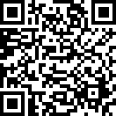

Blk:

32 Unit No.:

#01-02

QR Code For Room Transfer

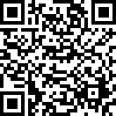

Blk:

32 Unit No.:

#02-01

QR Code For Room Transfer



Blk:

32 Unit No.:

#02-02

QR Code For Room Transfer



Blk:

32 Unit No.:

#02-03

QR Code For Room Transfer



Blk:

32 Unit No.:

#02-04

QR Code For Room Transfer



Blk:

32 Unit No.:

#02-05

QR Code For Room Transfer

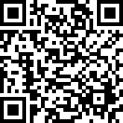

Blk:

32 Unit No.:

#02-10

QR Code For Room Transfer

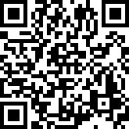

Blk:

32 Unit No.:

#02-11

QR Code For Room Transfer



Blk:

32 Unit No.:

#02-12

QR Code For Room Transfer



Blk:

32 Unit No.:

#02-13

QR Code For Room Transfer

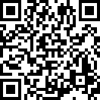

Blk:

32 Unit No.:

#02-14

QR Code For Room Transfer



Blk:

32 Unit No.:

#03-01

QR Code For Room Transfer

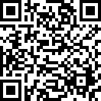

Blk:

32 Unit No.:

#03-02

QR Code For Room Transfer

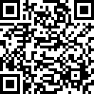

Blk:

32 Unit No.:

#03-03

QR Code For Room Transfer

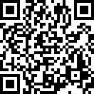

Blk:

32 Unit No.:

#03-04

QR Code For Room Transfer



Blk:

32 Unit No.:

#03-05

QR Code For Room Transfer



Blk:

32 Unit No.:

#03-06

QR Code For Room Transfer

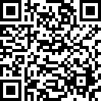

Blk:

32 Unit No.:

#03-07

QR Code For Room Transfer



Blk:

32 Unit No.:

#03-08

QR Code For Room Transfer

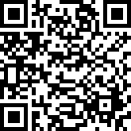

Blk:

32 Unit No.:

#03-09

QR Code For Room Transfer

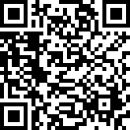

Blk:

32 Unit No.:

#03-10

QR Code For Room Transfer



Blk:

32 Unit No.:

#03-11

QR Code For Room Transfer

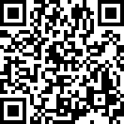

Blk:

32 Unit No.:

#03-12

QR Code For Room Transfer

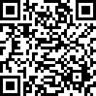

Blk:

32 Unit No.:

#03-13

QR Code For Room Transfer

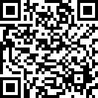

Blk:

32 Unit No.:

#03-14

QR Code For Room Transfer

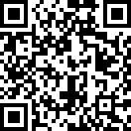

Blk:

32 Unit No.:

#04-01

QR Code For Room Transfer

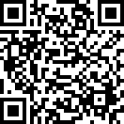

Blk:

32 Unit No.:

#04-02

QR Code For Room Transfer



Blk:

32 Unit No.:

#04-03

QR Code For Room Transfer



Blk:

32 Unit No.:

#04-04

QR Code For Room Transfer

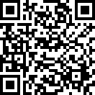

Blk:

32 Unit No.:

#04-05

QR Code For Room Transfer



Blk:

32 Unit No.:

#04-06

QR Code For Room Transfer

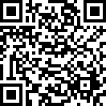

Blk:

32 Unit No.:

#04-07

QR Code For Room Transfer



Blk:

32 Unit No.:

#04-08

QR Code For Room Transfer

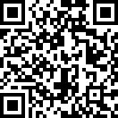

Blk:

32 Unit No.:

#04-09

QR Code For Room Transfer



Blk:

32 Unit No.:

#04-10

QR Code For Room Transfer

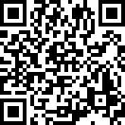

Blk:

32 Unit No.:

#04-11

QR Code For Room Transfer



Blk:

32 Unit No.:

#04-12

QR Code For Room Transfer



Blk:

32 Unit No.:

#04-13

QR Code For Room Transfer



Blk:

32 Unit No.:

#04-14

QR Code For Room Transfer

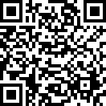

Blk:

32 Unit No.:

#05-01

QR Code For Room Transfer

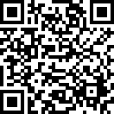

Blk:

32 Unit No.:

#05-02

QR Code For Room Transfer

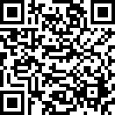

Blk:

32 Unit No.:

#05-03

QR Code For Room Transfer

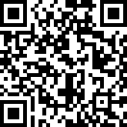

Blk:

32 Unit No.:

#05-04

QR Code For Room Transfer

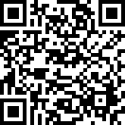

Blk:

32 Unit No.:

#05-05

QR Code For Room Transfer

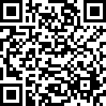

Blk:

32 Unit No.:

#05-06

QR Code For Room Transfer

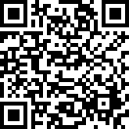

Blk:

32 Unit No.:

#05-07

QR Code For Room Transfer



Blk:

32 Unit No.:

#05-08

QR Code For Room Transfer

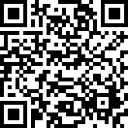

Blk:

32 Unit No.:

#05-09

QR Code For Room Transfer

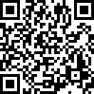

Blk:

32 Unit No.:

#05-10

QR Code For Room Transfer

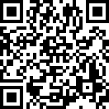

Blk:

32 Unit No.:

#05-11

QR Code For Room Transfer



Blk:

32 Unit No.:

#05-12

QR Code For Room Transfer



Blk:

32 Unit No.:

#05-13

QR Code For Room Transfer



Blk:

32 Unit No.:

#05-14

QR Code For Room Transfer

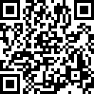

Blk:

32 Unit No.:

#06-01

QR Code For Room Transfer



Blk:

32 Unit No.:

#06-02

QR Code For Room Transfer



Blk:

32 Unit No.:

#06-03

QR Code For Room Transfer

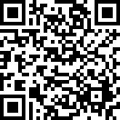

Blk:

32 Unit No.:

#06-04

QR Code For Room Transfer

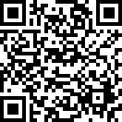

Blk:

32 Unit No.:

#06-05

QR Code For Room Transfer



Blk:

32 Unit No.:

#06-06

QR Code For Room Transfer



Blk:

32 Unit No.:

#06-07

QR Code For Room Transfer



Blk:

32 Unit No.:

#06-08

QR Code For Room Transfer



Blk:

32 Unit No.:

#06-09

QR Code For Room Transfer



Blk:

32 Unit No.:

#06-10

QR Code For Room Transfer

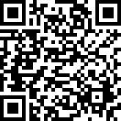

Blk:

32 Unit No.:

#06-11

QR Code For Room Transfer



Blk:

32 Unit No.:

#06-12

QR Code For Room Transfer

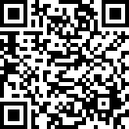

Blk:

32 Unit No.:

#06-13

QR Code For Room Transfer



Blk:

32 Unit No.:

#06-14

QR Code For Room Transfer



Blk:

32 Unit No.:

#07-01

QR Code For Room Transfer



Blk:

32 Unit No.:

#07-02

QR Code For Room Transfer



Blk:

32 Unit No.:

#07-03

QR Code For Room Transfer



Blk:

32 Unit No.:

#07-04

QR Code For Room Transfer



Blk:

32 Unit No.:

#07-05

QR Code For Room Transfer

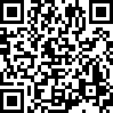

Blk:

32 Unit No.:

#07-06

QR Code For Room Transfer

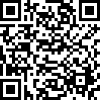

Blk:

32 Unit No.:

#07-07

QR Code For Room Transfer

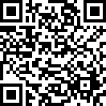

Blk:

32 Unit No.:

#07-08

QR Code For Room Transfer



Blk:

32 Unit No.:

#07-09

QR Code For Room Transfer



Blk:

32 Unit No.:

#07-10

QR Code For Room Transfer

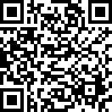

Blk:

32 Unit No.:

#07-11

QR Code For Room Transfer

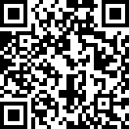

Blk:

32 Unit No.:

#07-12

QR Code For Room Transfer



Blk:

32 Unit No.:

#07-13

QR Code For Room Transfer

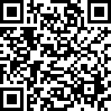

Blk:

32 Unit No.:

#07-14

QR Code For Room Transfer



Blk:

32 Unit No.:

#08-01

QR Code For Room Transfer

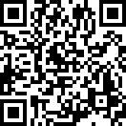

Blk:

32 Unit No.:

#08-02

QR Code For Room Transfer



Blk:

32 Unit No.:

#08-03

QR Code For Room Transfer

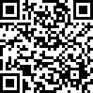

Blk:

32 Unit No.:

#08-04

QR Code For Room Transfer

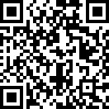

Blk:

32 Unit No.:

#08-05

QR Code For Room Transfer



Blk:

32 Unit No.:

#08-06

QR Code For Room Transfer



Blk:

32 Unit No.:

#08-07

QR Code For Room Transfer

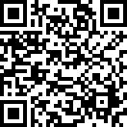

Blk:

32 Unit No.:

#08-08

QR Code For Room Transfer



Blk:

32 Unit No.:

#08-09

QR Code For Room Transfer



Blk:

32 Unit No.:

#08-10

QR Code For Room Transfer



Blk:

32 Unit No.:

#08-11

QR Code For Room Transfer

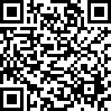

Blk:

32 Unit No.:

#08-12

QR Code For Room Transfer

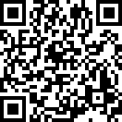

Blk:

32 Unit No.:

#08-13

QR Code For Room Transfer



Blk:

32 Unit No.:

#08-14

QR Code For Room Transfer



Blk:

32 Unit No.:

#09-01

QR Code For Room Transfer



Blk:

32 Unit No.:

#09-02

QR Code For Room Transfer

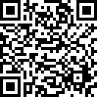

Blk:

32 Unit No.:

#09-03

QR Code For Room Transfer



Blk:

32 Unit No.:

#09-04

QR Code For Room Transfer

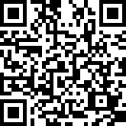

Blk:

32 Unit No.:

#09-05

QR Code For Room Transfer



Blk:

32 Unit No.:

#09-06

QR Code For Room Transfer

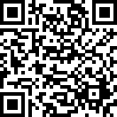

Blk:

32 Unit No.:

#09-07

QR Code For Room Transfer

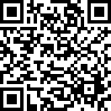

Blk:

32 Unit No.:

#09-08

QR Code For Room Transfer



Blk:

32 Unit No.:

#09-09

QR Code For Room Transfer

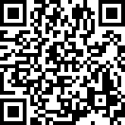

Blk:

32 Unit No.:

#09-10

QR Code For Room Transfer

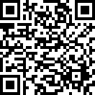

Blk:

32 Unit No.:

#09-11

QR Code For Room Transfer



Blk:

32 Unit No.:

#09-12

QR Code For Room Transfer



Blk:

32 Unit No.:

#09-13

QR Code For Room Transfer



Blk:

32 Unit No.:

#09-14

QR Code For Room Transfer

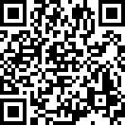

Blk:

32 Unit No.:

#10-01

QR Code For Room Transfer



Blk:

32 Unit No.:

#10-02

QR Code For Room Transfer



Blk:

32 Unit No.:

#10-03

QR Code For Room Transfer

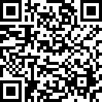

Blk:

32 Unit No.:

#10-04

QR Code For Room Transfer



Blk:

32 Unit No.:

#10-05

QR Code For Room Transfer

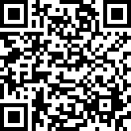

Blk:

32 Unit No.:

#10-06

QR Code For Room Transfer



Blk:

32 Unit No.:

#10-07

QR Code For Room Transfer

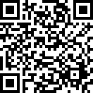

Blk:

32 Unit No.:

#10-08

QR Code For Room Transfer



Blk:

32 Unit No.:

#10-09

QR Code For Room Transfer

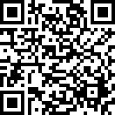

Blk:

32 Unit No.:

#10-10

QR Code For Room Transfer



Blk:

32 Unit No.:

#10-11

QR Code For Room Transfer

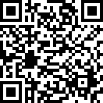

Blk:

32 Unit No.:

#10-12

QR Code For Room Transfer



Blk:

32 Unit No.:

#10-13

QR Code For Room Transfer



Blk:

32 Unit No.:

#10-14

QR Code For Room Transfer

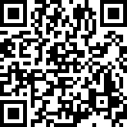

Blk:

32 Unit No.:

#11-01

QR Code For Room Transfer



Blk:

32 Unit No.:

#11-02

QR Code For Room Transfer

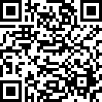

Blk:

32 Unit No.:

#11-03

QR Code For Room Transfer



Blk:

32 Unit No.:

#11-04

QR Code For Room Transfer



Blk:

32 Unit No.:

#11-05

QR Code For Room Transfer



Blk:

32 Unit No.:

#11-06

QR Code For Room Transfer



Blk:

32 Unit No.:

#11-07

QR Code For Room Transfer

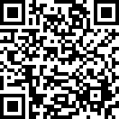

Blk:

32 Unit No.:

#11-08

QR Code For Room Transfer

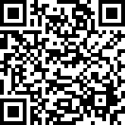

Blk:

32 Unit No.:

#11-09

QR Code For Room Transfer



Blk:

32 Unit No.:

#11-10

QR Code For Room Transfer

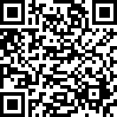

Blk:

32 Unit No.:

#11-11

QR Code For Room Transfer



Blk:

32 Unit No.:

#11-12

QR Code For Room Transfer



Blk:

32 Unit No.:

#11-13

QR Code For Room Transfer

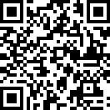

Blk:

32 Unit No.:

#11-14

QR Code For Room Transfer

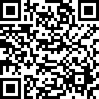

Blk:

32 Unit No.:

#12-01

QR Code For Room Transfer



Blk:

32 Unit No.:

#12-02

QR Code For Room Transfer

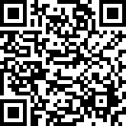

Blk:

32 Unit No.:

#12-03

QR Code For Room Transfer

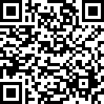

Blk:

32 Unit No.:

#12-04

QR Code For Room Transfer

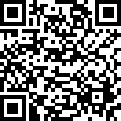

Blk:

32 Unit No.:

#12-05

QR Code For Room Transfer



Blk:

32 Unit No.:

#12-06

QR Code For Room Transfer



Blk:

32 Unit No.:

#12-07

QR Code For Room Transfer

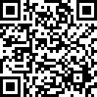

Blk:

32 Unit No.:

#12-08

QR Code For Room Transfer



Blk:

32 Unit No.:

#12-09

QR Code For Room Transfer



Blk:

32 Unit No.:

#12-10

QR Code For Room Transfer



Blk:

32 Unit No.:

#12-11

QR Code For Room Transfer



Blk:

32 Unit No.:

#12-12

QR Code For Room Transfer



Blk:

32 Unit No.:

#12-13

QR Code For Room Transfer



Blk:

32 Unit No.:

#12-14

QR Code For Room Transfer

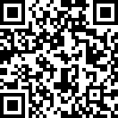

Blk:

34 Unit No.:

#02-15

QR Code For Room Transfer



Blk:

34 Unit No.:

#02-16

QR Code For Room Transfer

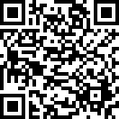

Blk:

34 Unit No.:

#02-17

QR Code For Room Transfer



Blk:

34 Unit No.:

#02-18

QR Code For Room Transfer

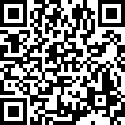

Blk:

34 Unit No.:

#02-19

QR Code For Room Transfer

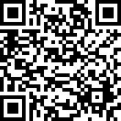

Blk:

34 Unit No.:

#02-24

QR Code For Room Transfer



Blk:

34 Unit No.:

#02-25

QR Code For Room Transfer



Blk:

34 Unit No.:

#02-26

QR Code For Room Transfer

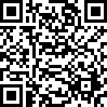

Blk:

34 Unit No.:

#02-27

QR Code For Room Transfer



Blk:

34 Unit No.:

#02-28

QR Code For Room Transfer

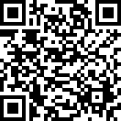

Blk:

34 Unit No.:

#03-15

QR Code For Room Transfer

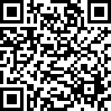

Blk:

34 Unit No.:

#03-16

QR Code For Room Transfer



Blk:

34 Unit No.:

#03-17

QR Code For Room Transfer

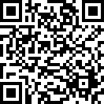

Blk:

34 Unit No.:

#03-18

QR Code For Room Transfer

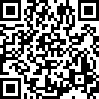

Blk:

34 Unit No.:

#03-19

QR Code For Room Transfer

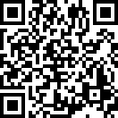

Blk:

34 Unit No.:

#03-20

QR Code For Room Transfer



Blk:

34 Unit No.:

#03-24

QR Code For Room Transfer



Blk:

34 Unit No.:

#03-25

QR Code For Room Transfer



Blk:

34 Unit No.:

#03-26

QR Code For Room Transfer

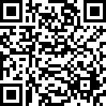

Blk:

34 Unit No.:

#03-27

QR Code For Room Transfer



Blk:

34 Unit No.:

#03-28

QR Code For Room Transfer



Blk:

34 Unit No.:

#04-15

QR Code For Room Transfer

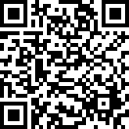

Blk:

34 Unit No.:

#04-16

QR Code For Room Transfer

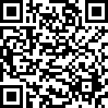

Blk:

34 Unit No.:

#04-17

QR Code For Room Transfer

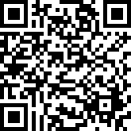

Blk:

34 Unit No.:

#04-18

QR Code For Room Transfer

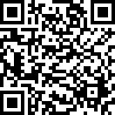

Blk:

34 Unit No.:

#04-19

QR Code For Room Transfer

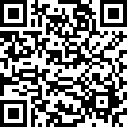

Blk:

34 Unit No.:

#04-20

QR Code For Room Transfer

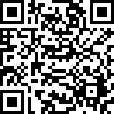

Blk:

34 Unit No.:

#04-21

QR Code For Room Transfer



Blk:

34 Unit No.:

#04-22

QR Code For Room Transfer



Blk:

34 Unit No.:

#04-23

QR Code For Room Transfer

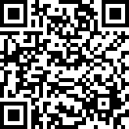

Blk:

34 Unit No.:

#04-24

QR Code For Room Transfer

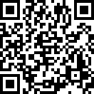

Blk:

34 Unit No.:

#04-25

QR Code For Room Transfer



Blk:

34 Unit No.:

#04-26

QR Code For Room Transfer



Blk:

34 Unit No.:

#04-27

QR Code For Room Transfer



Blk:

34 Unit No.:

#04-28

QR Code For Room Transfer



Blk:

34 Unit No.:

#05-15

QR Code For Room Transfer

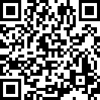

Blk:

34 Unit No.:

#05-16

QR Code For Room Transfer



Blk:

34 Unit No.:

#05-17

QR Code For Room Transfer



Blk:

34 Unit No.:

#05-18

QR Code For Room Transfer

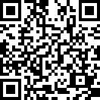

Blk:

34 Unit No.:

#05-19

QR Code For Room Transfer



Blk:

34 Unit No.:

#05-20

QR Code For Room Transfer



Blk:

34 Unit No.:

#05-21

QR Code For Room Transfer

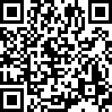

Blk:

34 Unit No.:

#05-22

QR Code For Room Transfer

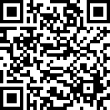

Blk:

34 Unit No.:

#05-23

QR Code For Room Transfer

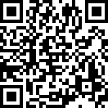

Blk:

34 Unit No.:

#05-24

QR Code For Room Transfer

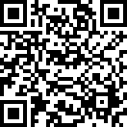

Blk:

34 Unit No.:

#05-25

QR Code For Room Transfer

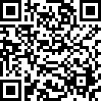

Blk:

34 Unit No.:

#05-26

QR Code For Room Transfer

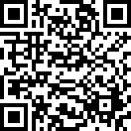

Blk:

34 Unit No.:

#05-27

QR Code For Room Transfer

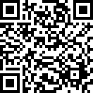

Blk:

34 Unit No.:

#05-28

QR Code For Room Transfer



Blk:

34 Unit No.:

#06-15

QR Code For Room Transfer



Blk:

34 Unit No.:

#06-16

QR Code For Room Transfer



Blk:

34 Unit No.:

#06-17

QR Code For Room Transfer



Blk:

34 Unit No.:

#06-18

QR Code For Room Transfer



Blk:

34 Unit No.:

#06-19

QR Code For Room Transfer

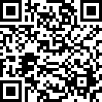

Blk:

34 Unit No.:

#06-20

QR Code For Room Transfer

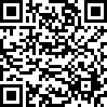

Blk:

34 Unit No.:

#06-21

QR Code For Room Transfer



Blk:

34 Unit No.:

#06-22

QR Code For Room Transfer



Blk:

34 Unit No.:

#06-23

QR Code For Room Transfer



Blk:

34 Unit No.:

#06-24

QR Code For Room Transfer

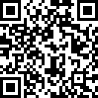

Blk:

34 Unit No.:

#06-25

QR Code For Room Transfer



Blk:

34 Unit No.:

#06-26

QR Code For Room Transfer

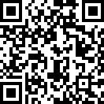

Blk:

34 Unit No.:

#06-27

QR Code For Room Transfer



Blk:

34 Unit No.:

#06-28

QR Code For Room Transfer

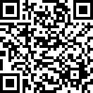

Blk:

34 Unit No.:

#07-15

QR Code For Room Transfer

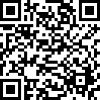

Blk:

34 Unit No.:

#07-16

QR Code For Room Transfer



Blk:

34 Unit No.:

#07-17

QR Code For Room Transfer



Blk:

34 Unit No.:

#07-18

QR Code For Room Transfer



Blk:

34 Unit No.:

#07-19

QR Code For Room Transfer



Blk:

34 Unit No.:

#07-20

QR Code For Room Transfer

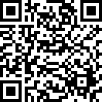

Blk:

34 Unit No.:

#07-21

QR Code For Room Transfer

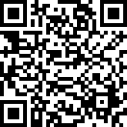

Blk:

34 Unit No.:

#07-22

QR Code For Room Transfer

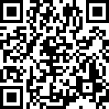

Blk:

34 Unit No.:

#07-23

QR Code For Room Transfer



Blk:

34 Unit No.:

#07-24

QR Code For Room Transfer



Blk:

34 Unit No.:

#07-25

QR Code For Room Transfer

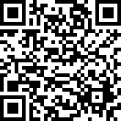

Blk:

34 Unit No.:

#07-26

QR Code For Room Transfer



Blk:

34 Unit No.:

#07-27

QR Code For Room Transfer



Blk:

34 Unit No.:

#07-28

QR Code For Room Transfer

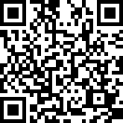

Blk:

34 Unit No.:

#08-15

QR Code For Room Transfer



Blk:

34 Unit No.:

#08-16

QR Code For Room Transfer

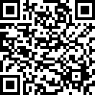

Blk:

34 Unit No.:

#08-17

QR Code For Room Transfer

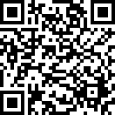

Blk:

34 Unit No.:

#08-18

QR Code For Room Transfer

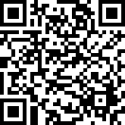

Blk:

34 Unit No.:

#08-19

QR Code For Room Transfer

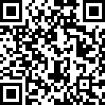

Blk:

34 Unit No.:

#08-20

QR Code For Room Transfer

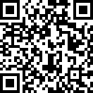

Blk:

34 Unit No.:

#08-21

QR Code For Room Transfer



Blk:

34 Unit No.:

#08-22

QR Code For Room Transfer

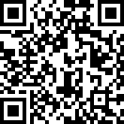

Blk:

34 Unit No.:

#08-23

QR Code For Room Transfer



Blk:

34 Unit No.:

#08-24

QR Code For Room Transfer

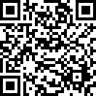

Blk:

34 Unit No.:

#08-25

QR Code For Room Transfer

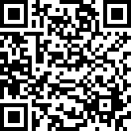

Blk:

34 Unit No.:

#08-26

QR Code For Room Transfer



Blk:

34 Unit No.:

#08-27

QR Code For Room Transfer

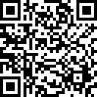

Blk:

34 Unit No.:

#08-28

QR Code For Room Transfer



Blk:

34 Unit No.:

#09-15

QR Code For Room Transfer



Blk:

34 Unit No.:

#09-16

QR Code For Room Transfer



Blk:

34 Unit No.:

#09-17

QR Code For Room Transfer

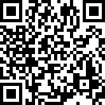

Blk:

34 Unit No.:

#09-18

QR Code For Room Transfer

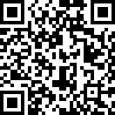

Blk:

34 Unit No.:

#09-19

QR Code For Room Transfer



Blk:

34 Unit No.:

#09-20

QR Code For Room Transfer



Blk:

34 Unit No.:

#09-21

QR Code For Room Transfer



Blk:

34 Unit No.:

#09-22

QR Code For Room Transfer

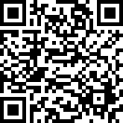

Blk:

34 Unit No.:

#09-23

QR Code For Room Transfer

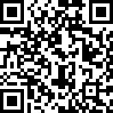

Blk:

34 Unit No.:

#09-24

QR Code For Room Transfer



Blk:

34 Unit No.:

#09-25

QR Code For Room Transfer

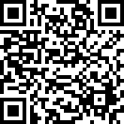

Blk:

34 Unit No.:

#09-26

QR Code For Room Transfer



Blk:

34 Unit No.:

#09-27

QR Code For Room Transfer



Blk:

34 Unit No.:

#09-28

QR Code For Room Transfer

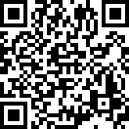

Blk:

34 Unit No.:

#10-15

QR Code For Room Transfer

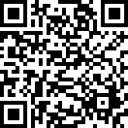

Blk:

34 Unit No.:

#10-16

QR Code For Room Transfer



Blk:

34 Unit No.:

#10-17

QR Code For Room Transfer

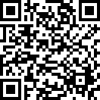

Blk:

34 Unit No.:

#10-18

QR Code For Room Transfer

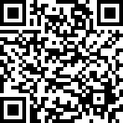

Blk:

34 Unit No.:

#10-19

QR Code For Room Transfer



Blk:

34 Unit No.:

#10-20

QR Code For Room Transfer

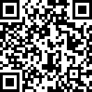

Blk:

34 Unit No.:

#10-21

QR Code For Room Transfer



Blk:

34 Unit No.:

#10-22

QR Code For Room Transfer



Blk:

34 Unit No.:

#10-23

QR Code For Room Transfer



Blk:

34 Unit No.:

#10-24

QR Code For Room Transfer

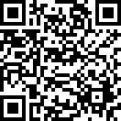

Blk:

34 Unit No.:

#10-25

QR Code For Room Transfer

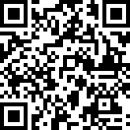

Blk:

34 Unit No.:

#10-26

QR Code For Room Transfer

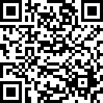

Blk:

34 Unit No.:

#10-27

QR Code For Room Transfer



Blk:

34 Unit No.:

#10-28

QR Code For Room Transfer



Blk:

34 Unit No.:

#11-15

QR Code For Room Transfer



Blk:

34 Unit No.:

#11-16

QR Code For Room Transfer



Blk:

34 Unit No.:

#11-17

QR Code For Room Transfer

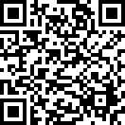

Blk:

34 Unit No.:

#11-18

QR Code For Room Transfer



Blk:

34 Unit No.:

#11-19

QR Code For Room Transfer

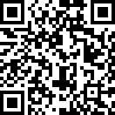

Blk:

34 Unit No.:

#11-20

QR Code For Room Transfer



Blk:

34 Unit No.:

#11-21

QR Code For Room Transfer

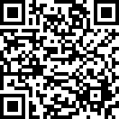

Blk:

34 Unit No.:

#11-22

QR Code For Room Transfer

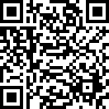

Blk:

34 Unit No.:

#11-23

QR Code For Room Transfer



Blk:

34 Unit No.:

#11-24

QR Code For Room Transfer

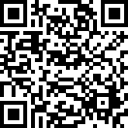

Blk:

34 Unit No.:

#11-25

QR Code For Room Transfer



Blk:

34 Unit No.:

#11-26

QR Code For Room Transfer



Blk:

34 Unit No.:

#11-27

QR Code For Room Transfer



Blk:

34 Unit No.:

#11-28

QR Code For Room Transfer



Blk:

34 Unit No.:

#12-15

QR Code For Room Transfer



Blk:

34 Unit No.:

#12-16

QR Code For Room Transfer



Blk:

34 Unit No.:

#12-17

QR Code For Room Transfer



Blk:

34 Unit No.:

#12-18

QR Code For Room Transfer

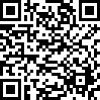

Blk:

34 Unit No.:

#12-19

QR Code For Room Transfer

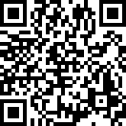

Blk:

34 Unit No.:

#12-20

QR Code For Room Transfer

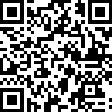

Blk:

34 Unit No.:

#12-21

QR Code For Room Transfer



Blk:

34 Unit No.:

#12-22

QR Code For Room Transfer



Blk:

34 Unit No.:

#12-23

QR Code For Room Transfer



Blk:

34 Unit No.:

#12-24

QR Code For Room Transfer

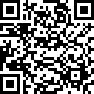

Blk:

34 Unit No.:

#12-25

QR Code For Room Transfer



Blk:

34 Unit No.:

#12-26

QR Code For Room Transfer



Blk:

34 Unit No.:

#12-27

QR Code For Room Transfer



Blk:

34 Unit No.:

#12-28

QR Code For Room Transfer

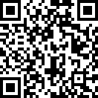

Blk:

36 Unit No.:

#02-29

QR Code For Room Transfer

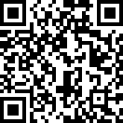

Blk:

36 Unit No.:

#02-30

QR Code For Room Transfer

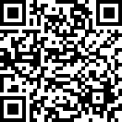

Blk:

36 Unit No.:

#02-31

QR Code For Room Transfer



Blk:

36 Unit No.:

#02-32

QR Code For Room Transfer

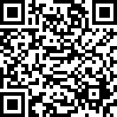

Blk:

36 Unit No.:

#02-33

QR Code For Room Transfer



Blk:

36 Unit No.:

#02-34

QR Code For Room Transfer



Blk:

36 Unit No.:

#02-35

QR Code For Room Transfer



Blk:

36 Unit No.:

#02-36

QR Code For Room Transfer



Blk:

36 Unit No.:

#02-37

QR Code For Room Transfer



Blk:

36 Unit No.:

#03-29

QR Code For Room Transfer



Blk:

36 Unit No.:

#03-30

QR Code For Room Transfer

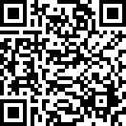

Blk:

36 Unit No.:

#03-31

QR Code For Room Transfer

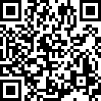

Blk:

36 Unit No.:

#03-32

QR Code For Room Transfer



Blk:

36 Unit No.:

#03-33

QR Code For Room Transfer



Blk:

36 Unit No.:

#03-34

QR Code For Room Transfer



Blk:

36 Unit No.:

#03-35

QR Code For Room Transfer

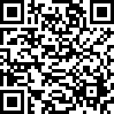

Blk:

36 Unit No.:

#03-36

QR Code For Room Transfer



Blk:

36 Unit No.:

#03-37

QR Code For Room Transfer

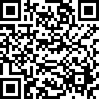

Blk:

36 Unit No.:

#04-29

QR Code For Room Transfer



Blk:

36 Unit No.:

#04-30

QR Code For Room Transfer

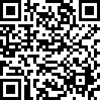

Blk:

36 Unit No.:

#04-31

QR Code For Room Transfer



Blk:

36 Unit No.:

#04-32

QR Code For Room Transfer

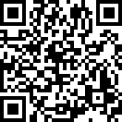

Blk:

36 Unit No.:

#04-33

QR Code For Room Transfer

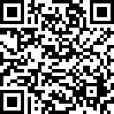

Blk:

36 Unit No.:

#04-34

QR Code For Room Transfer



Blk:

36 Unit No.:

#04-35

QR Code For Room Transfer



Blk:

36 Unit No.:

#04-36

QR Code For Room Transfer

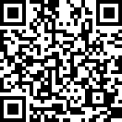

Blk:

36 Unit No.:

#04-37

QR Code For Room Transfer



Blk:

36 Unit No.:

#05-29

QR Code For Room Transfer

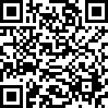

Blk:

36 Unit No.:

#05-30

QR Code For Room Transfer

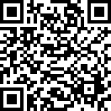

Blk:

36 Unit No.:

#05-31

QR Code For Room Transfer



Blk:

36 Unit No.:

#05-32

QR Code For Room Transfer



Blk:

36 Unit No.:

#05-33

QR Code For Room Transfer



Blk:

36 Unit No.:

#05-34

QR Code For Room Transfer



Blk:

36 Unit No.:

#05-35

QR Code For Room Transfer



Blk:

36 Unit No.:

#05-36

QR Code For Room Transfer



Blk:

36 Unit No.:

#05-37

QR Code For Room Transfer

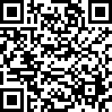

Blk:

36 Unit No.:

#06-29

QR Code For Room Transfer



Blk:

36 Unit No.:

#06-30

QR Code For Room Transfer



Blk:

36 Unit No.:

#06-31

QR Code For Room Transfer

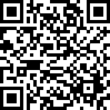

Blk:

36 Unit No.:

#06-32

QR Code For Room Transfer



Blk:

36 Unit No.:

#06-33

QR Code For Room Transfer

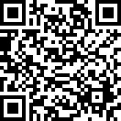

Blk:

36 Unit No.:

#06-34

QR Code For Room Transfer



Blk:

36 Unit No.:

#06-35

QR Code For Room Transfer



Blk:

36 Unit No.:

#06-36

QR Code For Room Transfer

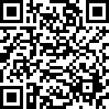

Blk:

36 Unit No.:

#06-37

QR Code For Room Transfer

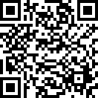

Blk:

36 Unit No.:

#07-29

QR Code For Room Transfer



Blk:

36 Unit No.:

#07-30

QR Code For Room Transfer

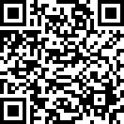

Blk:

36 Unit No.:

#07-31

QR Code For Room Transfer



Blk:

36 Unit No.:

#07-32

QR Code For Room Transfer



Blk:

36 Unit No.:

#07-33

QR Code For Room Transfer



Blk:

36 Unit No.:

#07-34

QR Code For Room Transfer

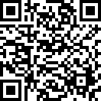

Blk:

36 Unit No.:

#07-35

QR Code For Room Transfer



Blk:

36 Unit No.:

#07-36

QR Code For Room Transfer

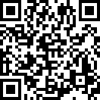

Blk:

36 Unit No.:

#07-37

QR Code For Room Transfer

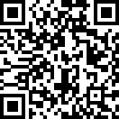

Blk:

36 Unit No.:

#08-29

QR Code For Room Transfer



Blk:

36 Unit No.:

#08-30

QR Code For Room Transfer



Blk:

36 Unit No.:

#08-31

QR Code For Room Transfer



Blk:

36 Unit No.:

#08-32

QR Code For Room Transfer



Blk:

36 Unit No.:

#08-33

QR Code For Room Transfer



Blk:

36 Unit No.:

#08-34

QR Code For Room Transfer



Blk:

36 Unit No.:

#08-35

QR Code For Room Transfer



Blk:

36 Unit No.:

#08-36

QR Code For Room Transfer



Blk:

36 Unit No.:

#08-37

QR Code For Room Transfer



Blk:

36 Unit No.:

#09-29

QR Code For Room Transfer



Blk:

36 Unit No.:

#09-30

QR Code For Room Transfer

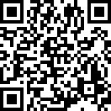

Blk:

36 Unit No.:

#09-31

QR Code For Room Transfer



Blk:

36 Unit No.:

#09-32

QR Code For Room Transfer

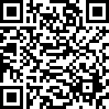

Blk:

36 Unit No.:

#09-33

QR Code For Room Transfer

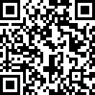

Blk:

36 Unit No.:

#09-34

QR Code For Room Transfer



Blk:

36 Unit No.:

#09-35

QR Code For Room Transfer

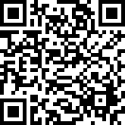

Blk:

36 Unit No.:

#09-36

QR Code For Room Transfer

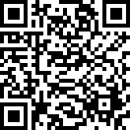

Blk:

36 Unit No.:

#09-37

QR Code For Room Transfer

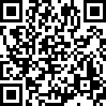

Blk:

36 Unit No.:

#10-29

QR Code For Room Transfer

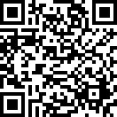

Blk:

36 Unit No.:

#10-30

QR Code For Room Transfer



Blk:

36 Unit No.:

#10-31

QR Code For Room Transfer



Blk:

36 Unit No.:

#10-32

QR Code For Room Transfer



Blk:

36 Unit No.:

#10-33

QR Code For Room Transfer

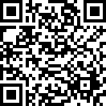

Blk:

36 Unit No.:

#10-34

QR Code For Room Transfer

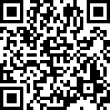

Blk:

36 Unit No.:

#10-35

QR Code For Room Transfer

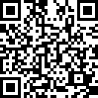

Blk:

36 Unit No.:

#10-36

QR Code For Room Transfer



Blk:

36 Unit No.:

#10-37

QR Code For Room Transfer



Blk:

36 Unit No.:

#11-29

QR Code For Room Transfer

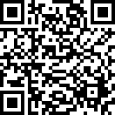

Blk:

36 Unit No.:

#11-30

QR Code For Room Transfer



Blk:

36 Unit No.:

#11-31

QR Code For Room Transfer



Blk:

36 Unit No.:

#11-32

QR Code For Room Transfer

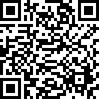

Blk:

36 Unit No.:

#11-33

QR Code For Room Transfer



Blk:

36 Unit No.:

#11-34

QR Code For Room Transfer



Blk:

36 Unit No.:

#11-35

QR Code For Room Transfer



Blk:

36 Unit No.:

#11-36

QR Code For Room Transfer



Blk:

36 Unit No.:

#11-37

QR Code For Room Transfer



Blk:

36 Unit No.:

#12-29

QR Code For Room Transfer



Blk:

36 Unit No.:

#12-30

QR Code For Room Transfer

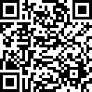

Blk:

36 Unit No.:

#12-31

QR Code For Room Transfer



Blk:

36 Unit No.:

#12-32

QR Code For Room Transfer



Blk:

36 Unit No.:

#12-33

QR Code For Room Transfer

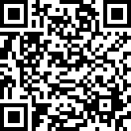

Blk:

36 Unit No.:

#12-34

QR Code For Room Transfer



Blk:

36 Unit No.:

#12-35

QR Code For Room Transfer

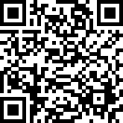

Blk:

36 Unit No.:

#12-36

QR Code For Room Transfer

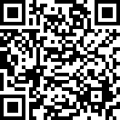

Blk:

36 Unit No.:

#12-37

