QR Code For Room Transfer



Blk:

14 Unit No.:

#01-08

QR Code For Room Transfer



Blk:

14 Unit No.:

#01-09

QR Code For Room Transfer



Blk:

14 Unit No.:

#01-10

QR Code For Room Transfer



Blk:

14 Unit No.:

#01-11

QR Code For Room Transfer

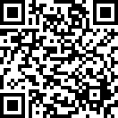

Blk:

14 Unit No.:

#01-12

QR Code For Room Transfer



Blk:

14 Unit No.:

#01-13

QR Code For Room Transfer



Blk:

14 Unit No.:

#01-14

QR Code For Room Transfer

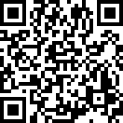

Blk:

14 Unit No.:

#01-15

QR Code For Room Transfer



Blk:

14 Unit No.:

#01-16

QR Code For Room Transfer

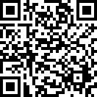

Blk:

14 Unit No.:

#01-17

QR Code For Room Transfer

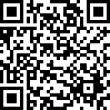

Blk:

14 Unit No.:

#02-08

QR Code For Room Transfer



Blk:

14 Unit No.:

#02-09

QR Code For Room Transfer



Blk:

14 Unit No.:

#02-10

QR Code For Room Transfer

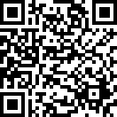

Blk:

14 Unit No.:

#02-11

QR Code For Room Transfer

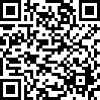

Blk:

14 Unit No.:

#02-12

QR Code For Room Transfer

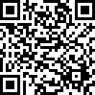

Blk:

14 Unit No.:

#02-13

QR Code For Room Transfer

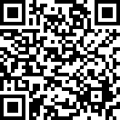

Blk:

14 Unit No.:

#02-14

QR Code For Room Transfer



Blk:

14 Unit No.:

#02-15

QR Code For Room Transfer

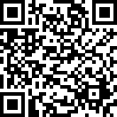

Blk:

14 Unit No.:

#02-16

QR Code For Room Transfer



Blk:

14 Unit No.:

#02-17

QR Code For Room Transfer



Blk:

14 Unit No.:

#03-08

QR Code For Room Transfer

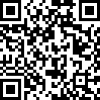

Blk:

14 Unit No.:

#03-09

QR Code For Room Transfer

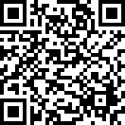

Blk:

14 Unit No.:

#03-10

QR Code For Room Transfer



Blk:

14 Unit No.:

#03-11

QR Code For Room Transfer



Blk:

14 Unit No.:

#03-12

QR Code For Room Transfer

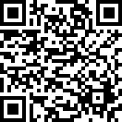

Blk:

14 Unit No.:

#03-13

QR Code For Room Transfer



Blk:

14 Unit No.:

#03-14

QR Code For Room Transfer

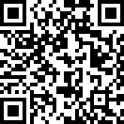

Blk:

14 Unit No.:

#03-15

QR Code For Room Transfer



Blk:

14 Unit No.:

#03-16

QR Code For Room Transfer



Blk:

14 Unit No.:

#03-17

QR Code For Room Transfer



Blk:

14 Unit No.:

#04-08

QR Code For Room Transfer



Blk:

14 Unit No.:

#04-09

QR Code For Room Transfer

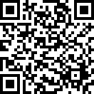

Blk:

14 Unit No.:

#04-10

QR Code For Room Transfer



Blk:

14 Unit No.:

#04-11

QR Code For Room Transfer



Blk:

14 Unit No.:

#04-12

QR Code For Room Transfer

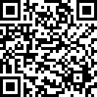

Blk:

14 Unit No.:

#04-13

QR Code For Room Transfer



Blk:

14 Unit No.:

#04-14

QR Code For Room Transfer



Blk:

14 Unit No.:

#04-15

QR Code For Room Transfer



Blk:

14 Unit No.:

#04-16

QR Code For Room Transfer



Blk:

14 Unit No.:

#04-17

QR Code For Room Transfer

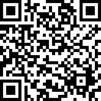

Blk:

14 Unit No.:

#05-08

QR Code For Room Transfer

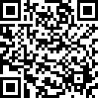

Blk:

14 Unit No.:

#05-09

QR Code For Room Transfer



Blk:

14 Unit No.:

#05-10

QR Code For Room Transfer

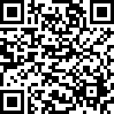

Blk:

14 Unit No.:

#05-11

QR Code For Room Transfer



Blk:

14 Unit No.:

#05-12

QR Code For Room Transfer

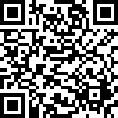

Blk:

14 Unit No.:

#05-13

QR Code For Room Transfer

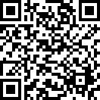

Blk:

14 Unit No.:

#05-14

QR Code For Room Transfer

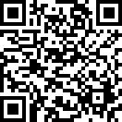

Blk:

14 Unit No.:

#05-15

QR Code For Room Transfer



Blk:

14 Unit No.:

#05-16

QR Code For Room Transfer



Blk:

14 Unit No.:

#05-17

QR Code For Room Transfer



Blk:

16 Unit No.:

#01-18

QR Code For Room Transfer

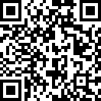

Blk:

16 Unit No.:

#01-19

QR Code For Room Transfer

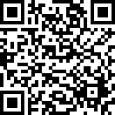

Blk:

16 Unit No.:

#01-20

QR Code For Room Transfer

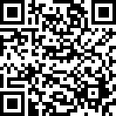

Blk:

16 Unit No.:

#01-21

QR Code For Room Transfer

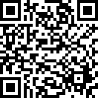

Blk:

16 Unit No.:

#01-22

QR Code For Room Transfer

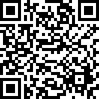

Blk:

16 Unit No.:

#01-23

QR Code For Room Transfer



Blk:

16 Unit No.:

#01-24

QR Code For Room Transfer

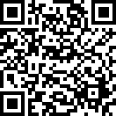

Blk:

16 Unit No.:

#01-25

QR Code For Room Transfer



Blk:

16 Unit No.:

#01-26

QR Code For Room Transfer



Blk:

16 Unit No.:

#01-27

QR Code For Room Transfer

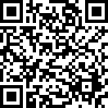

Blk:

16 Unit No.:

#02-18

QR Code For Room Transfer

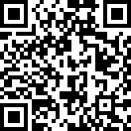

Blk:

16 Unit No.:

#02-19

QR Code For Room Transfer

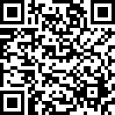

Blk:

16 Unit No.:

#02-20

QR Code For Room Transfer



Blk:

16 Unit No.:

#02-21

QR Code For Room Transfer



Blk:

16 Unit No.:

#02-22

QR Code For Room Transfer

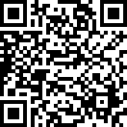

Blk:

16 Unit No.:

#02-23

QR Code For Room Transfer



Blk:

16 Unit No.:

#02-24

QR Code For Room Transfer

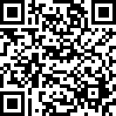

Blk:

16 Unit No.:

#02-25

QR Code For Room Transfer

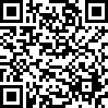

Blk:

16 Unit No.:

#02-26

QR Code For Room Transfer

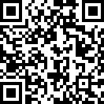

Blk:

16 Unit No.:

#02-27

QR Code For Room Transfer

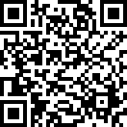

Blk:

16 Unit No.:

#03-18

QR Code For Room Transfer



Blk:

16 Unit No.:

#03-19

QR Code For Room Transfer



Blk:

16 Unit No.:

#03-20

QR Code For Room Transfer

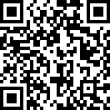

Blk:

16 Unit No.:

#03-21

QR Code For Room Transfer



Blk:

16 Unit No.:

#03-22

QR Code For Room Transfer



Blk:

16 Unit No.:

#03-23

QR Code For Room Transfer



Blk:

16 Unit No.:

#03-24

QR Code For Room Transfer

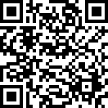

Blk:

16 Unit No.:

#03-25

QR Code For Room Transfer

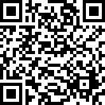

Blk:

16 Unit No.:

#03-26

QR Code For Room Transfer

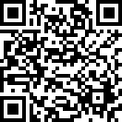

Blk:

16 Unit No.:

#03-27

QR Code For Room Transfer

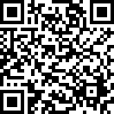

Blk:

16 Unit No.:

#04-18

QR Code For Room Transfer



Blk:

16 Unit No.:

#04-19

QR Code For Room Transfer

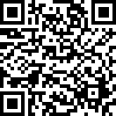

Blk:

16 Unit No.:

#04-20

QR Code For Room Transfer



Blk:

16 Unit No.:

#04-21

QR Code For Room Transfer

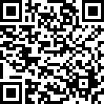

Blk:

16 Unit No.:

#04-22

QR Code For Room Transfer



Blk:

16 Unit No.:

#04-23

QR Code For Room Transfer



Blk:

16 Unit No.:

#04-24

QR Code For Room Transfer

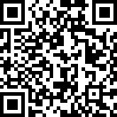

Blk:

16 Unit No.:

#04-25

QR Code For Room Transfer

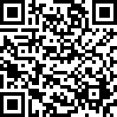

Blk:

16 Unit No.:

#04-26

QR Code For Room Transfer



Blk:

16 Unit No.:

#04-27

QR Code For Room Transfer

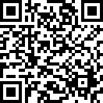

Blk:

16 Unit No.:

#05-18

QR Code For Room Transfer



Blk:

16 Unit No.:

#05-19

QR Code For Room Transfer



Blk:

16 Unit No.:

#05-20

QR Code For Room Transfer



Blk:

16 Unit No.:

#05-21

QR Code For Room Transfer



Blk:

16 Unit No.:

#05-22

QR Code For Room Transfer

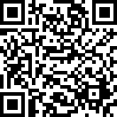

Blk:

16 Unit No.:

#05-23

QR Code For Room Transfer

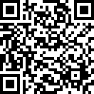

Blk:

16 Unit No.:

#05-24

QR Code For Room Transfer



Blk:

16 Unit No.:

#05-25

QR Code For Room Transfer

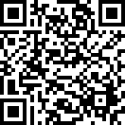

Blk:

16 Unit No.:

#05-26

QR Code For Room Transfer



Blk:

16 Unit No.:

#05-27

QR Code For Room Transfer



Blk:

18 Unit No.:

#01-28

QR Code For Room Transfer

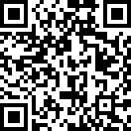

Blk:

18 Unit No.:

#01-29

QR Code For Room Transfer

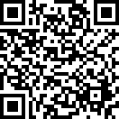

Blk:

18 Unit No.:

#01-30

QR Code For Room Transfer



Blk:

18 Unit No.:

#01-31

QR Code For Room Transfer

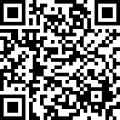

Blk:

18 Unit No.:

#01-32

QR Code For Room Transfer



Blk:

18 Unit No.:

#01-33

QR Code For Room Transfer

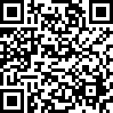

Blk:

18 Unit No.:

#01-34

QR Code For Room Transfer

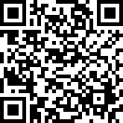

Blk:

18 Unit No.:

#01-35

QR Code For Room Transfer

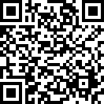

Blk:

18 Unit No.:

#01-36

QR Code For Room Transfer



Blk:

18 Unit No.:

#01-37

QR Code For Room Transfer

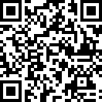

Blk:

18 Unit No.:

#02-28

QR Code For Room Transfer



Blk:

18 Unit No.:

#02-29

QR Code For Room Transfer



Blk:

18 Unit No.:

#02-30

QR Code For Room Transfer



Blk:

18 Unit No.:

#02-31

QR Code For Room Transfer

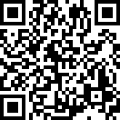

Blk:

18 Unit No.:

#02-32

QR Code For Room Transfer



Blk:

18 Unit No.:

#02-33

QR Code For Room Transfer

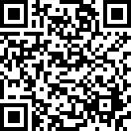

Blk:

18 Unit No.:

#02-34

QR Code For Room Transfer



Blk:

18 Unit No.:

#02-35

QR Code For Room Transfer

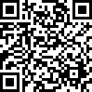

Blk:

18 Unit No.:

#02-36

QR Code For Room Transfer

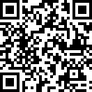

Blk:

18 Unit No.:

#02-37

QR Code For Room Transfer

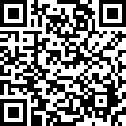

Blk:

18 Unit No.:

#03-28

QR Code For Room Transfer



Blk:

18 Unit No.:

#03-29

QR Code For Room Transfer



Blk:

18 Unit No.:

#03-30

QR Code For Room Transfer

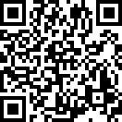

Blk:

18 Unit No.:

#03-31

QR Code For Room Transfer



Blk:

18 Unit No.:

#03-32

QR Code For Room Transfer



Blk:

18 Unit No.:

#03-33

QR Code For Room Transfer

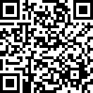

Blk:

18 Unit No.:

#03-34

QR Code For Room Transfer



Blk:

18 Unit No.:

#03-35

QR Code For Room Transfer

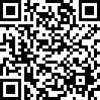

Blk:

18 Unit No.:

#03-36

QR Code For Room Transfer



Blk:

18 Unit No.:

#03-37

QR Code For Room Transfer

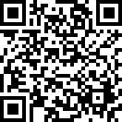

Blk:

18 Unit No.:

#04-28

QR Code For Room Transfer



Blk:

18 Unit No.:

#04-29

QR Code For Room Transfer

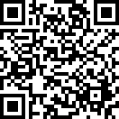

Blk:

18 Unit No.:

#04-30

QR Code For Room Transfer

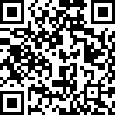

Blk:

18 Unit No.:

#04-31

QR Code For Room Transfer

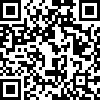

Blk:

18 Unit No.:

#04-32

QR Code For Room Transfer



Blk:

18 Unit No.:

#04-33

QR Code For Room Transfer

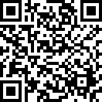

Blk:

18 Unit No.:

#04-34

QR Code For Room Transfer



Blk:

18 Unit No.:

#04-35

QR Code For Room Transfer



Blk:

18 Unit No.:

#04-36

QR Code For Room Transfer

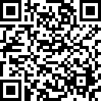

Blk:

18 Unit No.:

#04-37

QR Code For Room Transfer



Blk:

18 Unit No.:

#05-28

QR Code For Room Transfer



Blk:

18 Unit No.:

#05-29

QR Code For Room Transfer



Blk:

18 Unit No.:

#05-30

QR Code For Room Transfer



Blk:

18 Unit No.:

#05-31

QR Code For Room Transfer

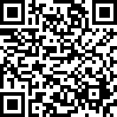

Blk:

18 Unit No.:

#05-32

QR Code For Room Transfer

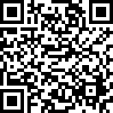

Blk:

18 Unit No.:

#05-33

QR Code For Room Transfer



Blk:

18 Unit No.:

#05-34

QR Code For Room Transfer



Blk:

18 Unit No.:

#05-35

QR Code For Room Transfer

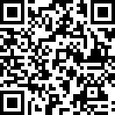

Blk:

18 Unit No.:

#05-36

QR Code For Room Transfer

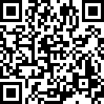

Blk:

18 Unit No.:

#05-37

QR Code For Room Transfer



Blk:

18 Unit No.:

#06-28

QR Code For Room Transfer



Blk:

18 Unit No.:

#06-29

QR Code For Room Transfer

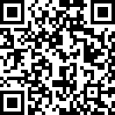

Blk:

18 Unit No.:

#06-30

QR Code For Room Transfer

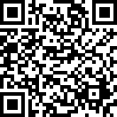

Blk:

18 Unit No.:

#06-31

QR Code For Room Transfer



Blk:

18 Unit No.:

#06-32

QR Code For Room Transfer

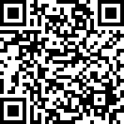

Blk:

18 Unit No.:

#06-33

QR Code For Room Transfer



Blk:

18 Unit No.:

#06-34

QR Code For Room Transfer

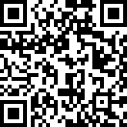

Blk:

18 Unit No.:

#06-35

QR Code For Room Transfer



Blk:

18 Unit No.:

#06-36

QR Code For Room Transfer

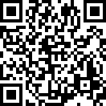

Blk:

18 Unit No.:

#06-37

QR Code For Room Transfer

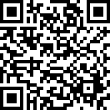

Blk:

20 Unit No.:

#01-38

QR Code For Room Transfer

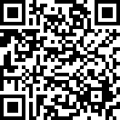

Blk:

20 Unit No.:

#01-39

QR Code For Room Transfer

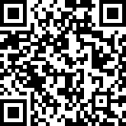

Blk:

20 Unit No.:

#01-40

QR Code For Room Transfer

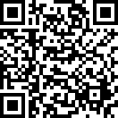

Blk:

20 Unit No.:

#01-41

QR Code For Room Transfer

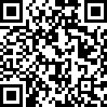

Blk:

20 Unit No.:

#01-42

QR Code For Room Transfer

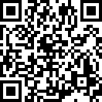

Blk:

20 Unit No.:

#01-43

QR Code For Room Transfer



Blk:

20 Unit No.:

#01-44

QR Code For Room Transfer

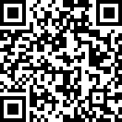

Blk:

20 Unit No.:

#01-45

QR Code For Room Transfer

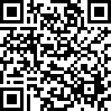

Blk:

20 Unit No.:

#01-46

QR Code For Room Transfer



Blk:

20 Unit No.:

#01-47

QR Code For Room Transfer

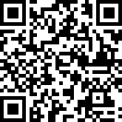

Blk:

20 Unit No.:

#01-48

QR Code For Room Transfer



Blk:

20 Unit No.:

#01-49

QR Code For Room Transfer



Blk:

20 Unit No.:

#01-50

QR Code For Room Transfer



Blk:

20 Unit No.:

#01-51

QR Code For Room Transfer



Blk:

20 Unit No.:

#01-52

QR Code For Room Transfer

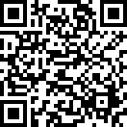

Blk:

20 Unit No.:

#01-53

QR Code For Room Transfer

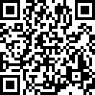

Blk:

20 Unit No.:

#01-54

QR Code For Room Transfer

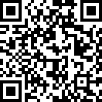

Blk:

20 Unit No.:

#01-55

QR Code For Room Transfer

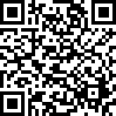

Blk:

20 Unit No.:

#01-56

QR Code For Room Transfer



Blk:

20 Unit No.:

#01-57

QR Code For Room Transfer



Blk:

20 Unit No.:

#02-38

QR Code For Room Transfer



Blk:

20 Unit No.:

#02-39

QR Code For Room Transfer

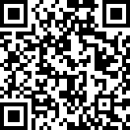

Blk:

20 Unit No.:

#02-40

QR Code For Room Transfer



Blk:

20 Unit No.:

#02-41

QR Code For Room Transfer



Blk:

20 Unit No.:

#02-42

QR Code For Room Transfer

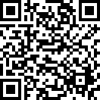

Blk:

20 Unit No.:

#02-43

QR Code For Room Transfer



Blk:

20 Unit No.:

#02-44

QR Code For Room Transfer



Blk:

20 Unit No.:

#02-45

QR Code For Room Transfer



Blk:

20 Unit No.:

#02-46

QR Code For Room Transfer



Blk:

20 Unit No.:

#02-47

QR Code For Room Transfer



Blk:

20 Unit No.:

#02-48

QR Code For Room Transfer

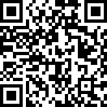

Blk:

20 Unit No.:

#02-49

QR Code For Room Transfer



Blk:

20 Unit No.:

#02-50

QR Code For Room Transfer



Blk:

20 Unit No.:

#02-51

QR Code For Room Transfer

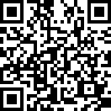

Blk:

20 Unit No.:

#02-52

QR Code For Room Transfer

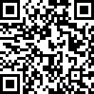

Blk:

20 Unit No.:

#02-53

QR Code For Room Transfer



Blk:

20 Unit No.:

#02-54

QR Code For Room Transfer

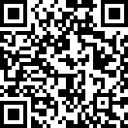

Blk:

20 Unit No.:

#02-55

QR Code For Room Transfer

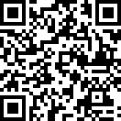

Blk:

20 Unit No.:

#02-56

QR Code For Room Transfer



Blk:

20 Unit No.:

#02-57

QR Code For Room Transfer



Blk:

20 Unit No.:

#03-38

QR Code For Room Transfer



Blk:

20 Unit No.:

#03-39

QR Code For Room Transfer



Blk:

20 Unit No.:

#03-40

QR Code For Room Transfer

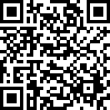

Blk:

20 Unit No.:

#03-41

QR Code For Room Transfer



Blk:

20 Unit No.:

#03-42

QR Code For Room Transfer

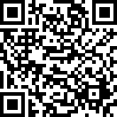

Blk:

20 Unit No.:

#03-43

QR Code For Room Transfer

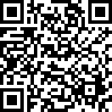

Blk:

20 Unit No.:

#03-44

QR Code For Room Transfer



Blk:

20 Unit No.:

#03-45

QR Code For Room Transfer



Blk:

20 Unit No.:

#03-46

QR Code For Room Transfer



Blk:

20 Unit No.:

#03-47

QR Code For Room Transfer

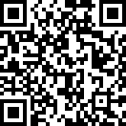

Blk:

20 Unit No.:

#03-48

QR Code For Room Transfer

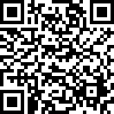

Blk:

20 Unit No.:

#03-49

QR Code For Room Transfer

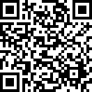

Blk:

20 Unit No.:

#03-50

QR Code For Room Transfer

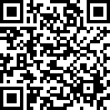

Blk:

20 Unit No.:

#03-51

QR Code For Room Transfer



Blk:

20 Unit No.:

#03-52

QR Code For Room Transfer

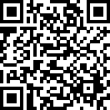

Blk:

20 Unit No.:

#03-53

QR Code For Room Transfer



Blk:

20 Unit No.:

#03-54

QR Code For Room Transfer



Blk:

20 Unit No.:

#03-55

QR Code For Room Transfer



Blk:

20 Unit No.:

#03-56

QR Code For Room Transfer

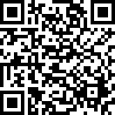

Blk:

20 Unit No.:

#03-57

QR Code For Room Transfer

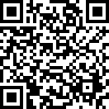

Blk:

20 Unit No.:

#04-38

QR Code For Room Transfer

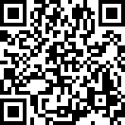

Blk:

20 Unit No.:

#04-39

QR Code For Room Transfer

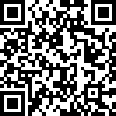

Blk:

20 Unit No.:

#04-40

QR Code For Room Transfer

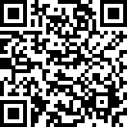

Blk:

20 Unit No.:

#04-41

QR Code For Room Transfer

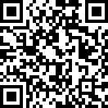

Blk:

20 Unit No.:

#04-42

QR Code For Room Transfer



Blk:

20 Unit No.:

#04-43

QR Code For Room Transfer

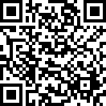

Blk:

20 Unit No.:

#04-44

QR Code For Room Transfer

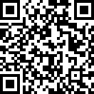

Blk:

20 Unit No.:

#04-45

QR Code For Room Transfer



Blk:

20 Unit No.:

#04-46

QR Code For Room Transfer



Blk:

20 Unit No.:

#04-47

QR Code For Room Transfer

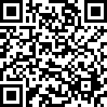

Blk:

20 Unit No.:

#04-48

QR Code For Room Transfer

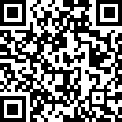

Blk:

20 Unit No.:

#04-49

QR Code For Room Transfer

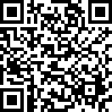

Blk:

20 Unit No.:

#04-50

QR Code For Room Transfer



Blk:

20 Unit No.:

#04-51

QR Code For Room Transfer

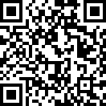

Blk:

20 Unit No.:

#04-52

QR Code For Room Transfer



Blk:

20 Unit No.:

#04-53

QR Code For Room Transfer

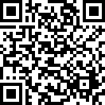

Blk:

20 Unit No.:

#04-54

QR Code For Room Transfer

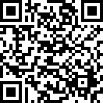

Blk:

20 Unit No.:

#04-55

QR Code For Room Transfer



Blk:

20 Unit No.:

#04-56

QR Code For Room Transfer

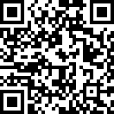

Blk:

20 Unit No.:

#04-57

QR Code For Room Transfer

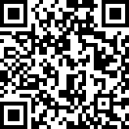

Blk:

20 Unit No.:

#05-38

QR Code For Room Transfer

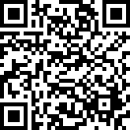

Blk:

20 Unit No.:

#05-39

QR Code For Room Transfer

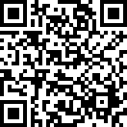

Blk:

20 Unit No.:

#05-40

QR Code For Room Transfer



Blk:

20 Unit No.:

#05-41

QR Code For Room Transfer

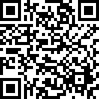

Blk:

20 Unit No.:

#05-42

QR Code For Room Transfer

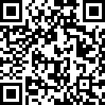

Blk:

20 Unit No.:

#05-43

QR Code For Room Transfer

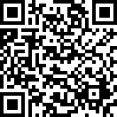

Blk:

20 Unit No.:

#05-44

QR Code For Room Transfer

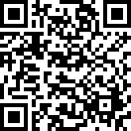

Blk:

20 Unit No.:

#05-45

QR Code For Room Transfer



Blk:

20 Unit No.:

#05-46

QR Code For Room Transfer



Blk:

20 Unit No.:

#05-47

QR Code For Room Transfer



Blk:

20 Unit No.:

#05-48

QR Code For Room Transfer



Blk:

20 Unit No.:

#05-49

QR Code For Room Transfer



Blk:

20 Unit No.:

#05-50

QR Code For Room Transfer



Blk:

20 Unit No.:

#05-51

QR Code For Room Transfer

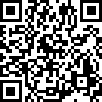

Blk:

20 Unit No.:

#05-52

QR Code For Room Transfer

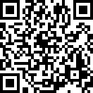

Blk:

20 Unit No.:

#05-53

QR Code For Room Transfer



Blk:

20 Unit No.:

#05-54

QR Code For Room Transfer

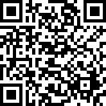

Blk:

20 Unit No.:

#05-55

QR Code For Room Transfer

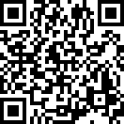

Blk:

20 Unit No.:

#05-56

QR Code For Room Transfer



Blk:

20 Unit No.:

#05-57

QR Code For Room Transfer



Blk:

20 Unit No.:

#06-38

QR Code For Room Transfer

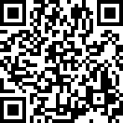

Blk:

20 Unit No.:

#06-39

QR Code For Room Transfer



Blk:

20 Unit No.:

#06-40

QR Code For Room Transfer

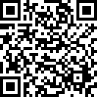

Blk:

20 Unit No.:

#06-41

QR Code For Room Transfer



Blk:

20 Unit No.:

#06-42

QR Code For Room Transfer

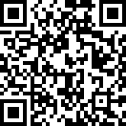

Blk:

20 Unit No.:

#06-43

QR Code For Room Transfer



Blk:

20 Unit No.:

#06-44

QR Code For Room Transfer



Blk:

20 Unit No.:

#06-45

QR Code For Room Transfer

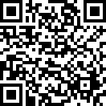

Blk:

20 Unit No.:

#06-46

QR Code For Room Transfer



Blk:

20 Unit No.:

#06-47

QR Code For Room Transfer



Blk:

20 Unit No.:

#06-48

QR Code For Room Transfer

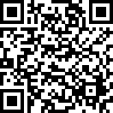

Blk:

20 Unit No.:

#06-49

QR Code For Room Transfer

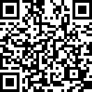

Blk:

20 Unit No.:

#06-50

QR Code For Room Transfer

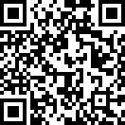

Blk:

20 Unit No.:

#06-51

QR Code For Room Transfer



Blk:

20 Unit No.:

#06-52

QR Code For Room Transfer



Blk:

20 Unit No.:

#06-53

QR Code For Room Transfer



Blk:

20 Unit No.:

#06-54

QR Code For Room Transfer

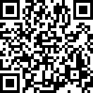

Blk:

20 Unit No.:

#06-55

QR Code For Room Transfer



Blk:

20 Unit No.:

#06-56

QR Code For Room Transfer



Blk:

20 Unit No.:

#06-57

QR Code For Room Transfer



Blk:

22 Unit No.:

#01-58

QR Code For Room Transfer



Blk:

22 Unit No.:

#01-59

QR Code For Room Transfer

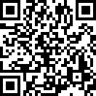

Blk:

22 Unit No.:

#01-60

QR Code For Room Transfer

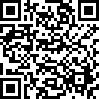

Blk:

22 Unit No.:

#01-61

QR Code For Room Transfer



Blk:

22 Unit No.:

#01-62

QR Code For Room Transfer



Blk:

22 Unit No.:

#01-63

QR Code For Room Transfer



Blk:

22 Unit No.:

#01-64

QR Code For Room Transfer

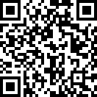

Blk:

22 Unit No.:

#01-65

QR Code For Room Transfer



Blk:

22 Unit No.:

#02-58

QR Code For Room Transfer



Blk:

22 Unit No.:

#02-59

QR Code For Room Transfer

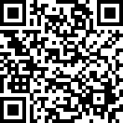

Blk:

22 Unit No.:

#02-60

QR Code For Room Transfer



Blk:

22 Unit No.:

#02-61

QR Code For Room Transfer

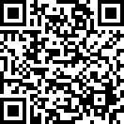

Blk:

22 Unit No.:

#02-62

QR Code For Room Transfer

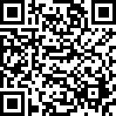

Blk:

22 Unit No.:

#02-63

QR Code For Room Transfer

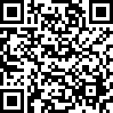

Blk:

22 Unit No.:

#02-64

QR Code For Room Transfer

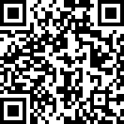

Blk:

22 Unit No.:

#02-65

QR Code For Room Transfer

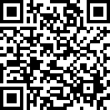

Blk:

22 Unit No.:

#03-58

QR Code For Room Transfer



Blk:

22 Unit No.:

#03-59

QR Code For Room Transfer

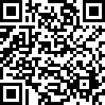

Blk:

22 Unit No.:

#03-60

QR Code For Room Transfer

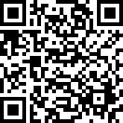

Blk:

22 Unit No.:

#03-61

QR Code For Room Transfer

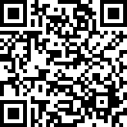

Blk:

22 Unit No.:

#03-62

QR Code For Room Transfer



Blk:

22 Unit No.:

#03-63

QR Code For Room Transfer



Blk:

22 Unit No.:

#03-64

QR Code For Room Transfer



Blk:

22 Unit No.:

#03-65

QR Code For Room Transfer

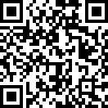

Blk:

22 Unit No.:

#04-58

QR Code For Room Transfer

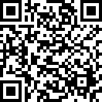

Blk:

22 Unit No.:

#04-59

QR Code For Room Transfer



Blk:

22 Unit No.:

#04-60

QR Code For Room Transfer



Blk:

22 Unit No.:

#04-61

QR Code For Room Transfer



Blk:

22 Unit No.:

#04-62

QR Code For Room Transfer



Blk:

22 Unit No.:

#04-63

QR Code For Room Transfer



Blk:

22 Unit No.:

#04-64

QR Code For Room Transfer



Blk:

22 Unit No.:

#04-65

QR Code For Room Transfer



Blk:

22 Unit No.:

#05-58

QR Code For Room Transfer



Blk:

22 Unit No.:

#05-59

QR Code For Room Transfer

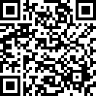

Blk:

22 Unit No.:

#05-60

QR Code For Room Transfer



Blk:

22 Unit No.:

#05-61

QR Code For Room Transfer



Blk:

22 Unit No.:

#05-62

QR Code For Room Transfer

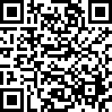

Blk:

22 Unit No.:

#05-63

QR Code For Room Transfer

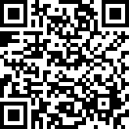

Blk:

22 Unit No.:

#05-64

QR Code For Room Transfer



Blk:

22 Unit No.:

#05-65

QR Code For Room Transfer

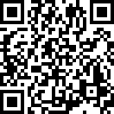

Blk:

22 Unit No.:

#06-58

QR Code For Room Transfer



Blk:

22 Unit No.:

#06-59

QR Code For Room Transfer

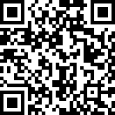

Blk:

22 Unit No.:

#06-60

QR Code For Room Transfer



Blk:

22 Unit No.:

#06-61

QR Code For Room Transfer



Blk:

22 Unit No.:

#06-62

QR Code For Room Transfer



Blk:

22 Unit No.:

#06-63

QR Code For Room Transfer

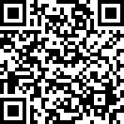

Blk:

22 Unit No.:

#06-64

QR Code For Room Transfer



Blk:

22 Unit No.:

#06-65

QR Code For Room Transfer



Blk:

24 Unit No.:

#01-66

QR Code For Room Transfer

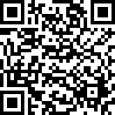

Blk:

24 Unit No.:

#01-67

QR Code For Room Transfer



Blk:

24 Unit No.:

#01-68

QR Code For Room Transfer

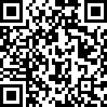

Blk:

24 Unit No.:

#01-69

QR Code For Room Transfer



Blk:

24 Unit No.:

#01-70

QR Code For Room Transfer

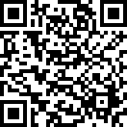

Blk:

24 Unit No.:

#01-71

QR Code For Room Transfer

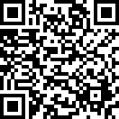

Blk:

24 Unit No.:

#01-72

QR Code For Room Transfer

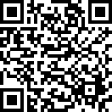

Blk:

24 Unit No.:

#01-73

QR Code For Room Transfer



Blk:

24 Unit No.:

#02-66

QR Code For Room Transfer

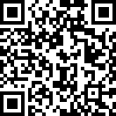

Blk:

24 Unit No.:

#02-67

QR Code For Room Transfer



Blk:

24 Unit No.:

#02-68

QR Code For Room Transfer

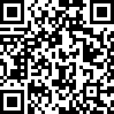

Blk:

24 Unit No.:

#02-69

QR Code For Room Transfer

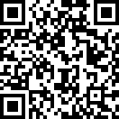

Blk:

24 Unit No.:

#02-70

QR Code For Room Transfer



Blk:

24 Unit No.:

#02-71

QR Code For Room Transfer

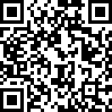

Blk:

24 Unit No.:

#02-72

QR Code For Room Transfer

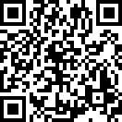

Blk:

24 Unit No.:

#02-73

QR Code For Room Transfer



Blk:

24 Unit No.:

#03-66

QR Code For Room Transfer



Blk:

24 Unit No.:

#03-67

QR Code For Room Transfer



Blk:

24 Unit No.:

#03-68

QR Code For Room Transfer



Blk:

24 Unit No.:

#03-69

QR Code For Room Transfer



Blk:

24 Unit No.:

#03-70

QR Code For Room Transfer

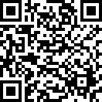

Blk:

24 Unit No.:

#03-71

QR Code For Room Transfer



Blk:

24 Unit No.:

#03-72

QR Code For Room Transfer

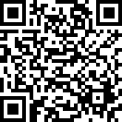

Blk:

24 Unit No.:

#03-73

QR Code For Room Transfer



Blk:

24 Unit No.:

#04-66

QR Code For Room Transfer



Blk:

24 Unit No.:

#04-67

QR Code For Room Transfer



Blk:

24 Unit No.:

#04-68

QR Code For Room Transfer

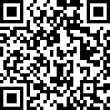

Blk:

24 Unit No.:

#04-69

QR Code For Room Transfer

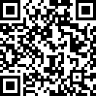

Blk:

24 Unit No.:

#04-70

QR Code For Room Transfer

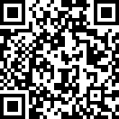

Blk:

24 Unit No.:

#04-71

QR Code For Room Transfer

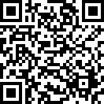

Blk:

24 Unit No.:

#04-72

QR Code For Room Transfer

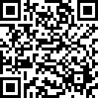

Blk:

24 Unit No.:

#04-73

QR Code For Room Transfer

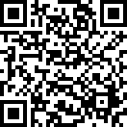

Blk:

24 Unit No.:

#05-66

QR Code For Room Transfer

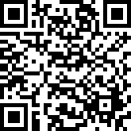

Blk:

24 Unit No.:

#05-67

QR Code For Room Transfer

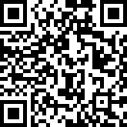

Blk:

24 Unit No.:

#05-68

QR Code For Room Transfer

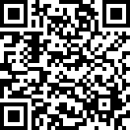

Blk:

24 Unit No.:

#05-69

QR Code For Room Transfer

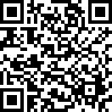

Blk:

24 Unit No.:

#05-70

QR Code For Room Transfer

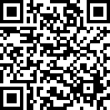

Blk:

24 Unit No.:

#05-71

QR Code For Room Transfer

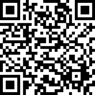

Blk:

24 Unit No.:

#05-72

QR Code For Room Transfer

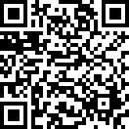

Blk:

24 Unit No.:

#05-73

QR Code For Room Transfer

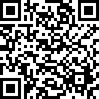

Blk:

26 Unit No.:

#01-74

QR Code For Room Transfer

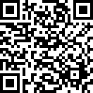

Blk:

26 Unit No.:

#01-75

QR Code For Room Transfer

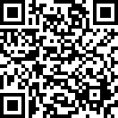

Blk:

26 Unit No.:

#01-76

QR Code For Room Transfer

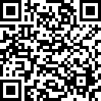

Blk:

26 Unit No.:

#01-77

QR Code For Room Transfer

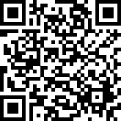

Blk:

26 Unit No.:

#01-78

QR Code For Room Transfer



Blk:

26 Unit No.:

#01-79

QR Code For Room Transfer

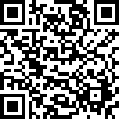

Blk:

26 Unit No.:

#01-80

QR Code For Room Transfer

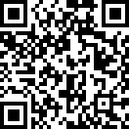

Blk:

26 Unit No.:

#01-81

QR Code For Room Transfer



Blk:

26 Unit No.:

#02-74

QR Code For Room Transfer



Blk:

26 Unit No.:

#02-75

QR Code For Room Transfer

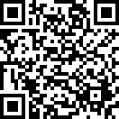

Blk:

26 Unit No.:

#02-76

QR Code For Room Transfer

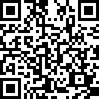

Blk:

26 Unit No.:

#02-77

QR Code For Room Transfer



Blk:

26 Unit No.:

#02-78

QR Code For Room Transfer

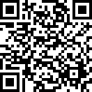

Blk:

26 Unit No.:

#02-79

QR Code For Room Transfer

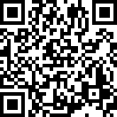

Blk:

26 Unit No.:

#02-80

QR Code For Room Transfer

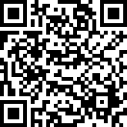

Blk:

26 Unit No.:

#02-81

QR Code For Room Transfer

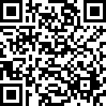

Blk:

26 Unit No.:

#03-74

QR Code For Room Transfer



Blk:

26 Unit No.:

#03-75

QR Code For Room Transfer



Blk:

26 Unit No.:

#03-76

QR Code For Room Transfer



Blk:

26 Unit No.:

#03-77

QR Code For Room Transfer



Blk:

26 Unit No.:

#03-78

QR Code For Room Transfer



Blk:

26 Unit No.:

#03-79

QR Code For Room Transfer

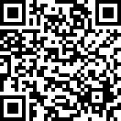

Blk:

26 Unit No.:

#03-80

QR Code For Room Transfer

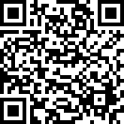

Blk:

26 Unit No.:

#03-81

QR Code For Room Transfer

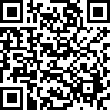

Blk:

26 Unit No.:

#04-74

QR Code For Room Transfer

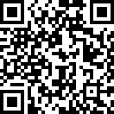

Blk:

26 Unit No.:

#04-75

QR Code For Room Transfer

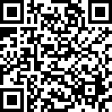

Blk:

26 Unit No.:

#04-76

QR Code For Room Transfer



Blk:

26 Unit No.:

#04-77

QR Code For Room Transfer

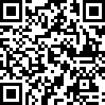

Blk:

26 Unit No.:

#04-78

QR Code For Room Transfer



Blk:

26 Unit No.:

#04-79

QR Code For Room Transfer

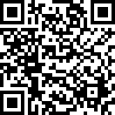

Blk:

26 Unit No.:

#04-80

QR Code For Room Transfer



Blk:

26 Unit No.:

#04-81

QR Code For Room Transfer

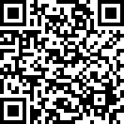

Blk:

26 Unit No.:

#05-74

QR Code For Room Transfer



Blk:

26 Unit No.:

#05-75

QR Code For Room Transfer

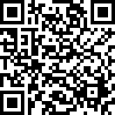

Blk:

26 Unit No.:

#05-76

QR Code For Room Transfer



Blk:

26 Unit No.:

#05-77

QR Code For Room Transfer

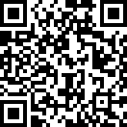

Blk:

26 Unit No.:

#05-78

QR Code For Room Transfer

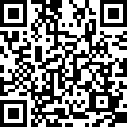

Blk:

26 Unit No.:

#05-79

QR Code For Room Transfer

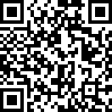

Blk:

26 Unit No.:

#05-80

QR Code For Room Transfer

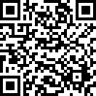

Blk:

26 Unit No.:

#05-81

QR Code For Room Transfer

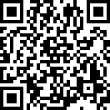

Blk:

28 Unit No.:

#01-01

QR Code For Room Transfer



Blk:

28 Unit No.:

#02-02

QR Code For Room Transfer

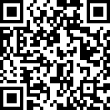

Blk:

28 Unit No.:

#03-01

QR Code For Room Transfer

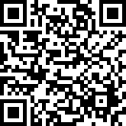

Blk:

28 Unit No.:

#03-02

QR Code For Room Transfer

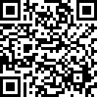

Blk:

28 Unit No.:

#03-03

QR Code For Room Transfer



Blk:

28 Unit No.:

#03-04

QR Code For Room Transfer

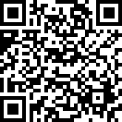

Blk:

28 Unit No.:

#03-05

QR Code For Room Transfer

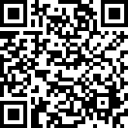

Blk:

28 Unit No.:

#03-06

QR Code For Room Transfer



Blk:

28 Unit No.:

#03-07

QR Code For Room Transfer



Blk:

28 Unit No.:

#03-08

QR Code For Room Transfer

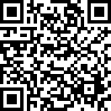

Blk:

28 Unit No.:

#03-09

QR Code For Room Transfer



Blk:

28 Unit No.:

#03-15

QR Code For Room Transfer

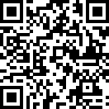

Blk:

28 Unit No.:

#03-16

QR Code For Room Transfer

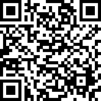

Blk:

28 Unit No.:

#03-17

QR Code For Room Transfer



Blk:

28 Unit No.:

#03-18

QR Code For Room Transfer



Blk:

28 Unit No.:

#04-01

QR Code For Room Transfer



Blk:

28 Unit No.:

#04-02

QR Code For Room Transfer



Blk:

28 Unit No.:

#04-03

QR Code For Room Transfer

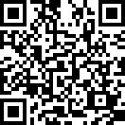

Blk:

28 Unit No.:

#04-04

QR Code For Room Transfer

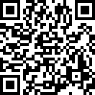

Blk:

28 Unit No.:

#04-05

QR Code For Room Transfer



Blk:

28 Unit No.:

#04-06

QR Code For Room Transfer

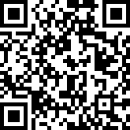

Blk:

28 Unit No.:

#04-07

QR Code For Room Transfer



Blk:

28 Unit No.:

#04-08

QR Code For Room Transfer

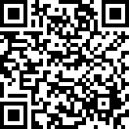

Blk:

28 Unit No.:

#04-09

QR Code For Room Transfer



Blk:

28 Unit No.:

#04-10

QR Code For Room Transfer

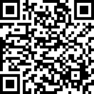

Blk:

28 Unit No.:

#04-11

QR Code For Room Transfer

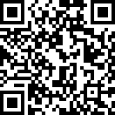

Blk:

28 Unit No.:

#04-12

QR Code For Room Transfer



Blk:

28 Unit No.:

#04-13

QR Code For Room Transfer



Blk:

28 Unit No.:

#04-14

QR Code For Room Transfer



Blk:

28 Unit No.:

#04-15

QR Code For Room Transfer



Blk:

28 Unit No.:

#04-16

QR Code For Room Transfer

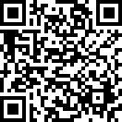

Blk:

28 Unit No.:

#04-17

QR Code For Room Transfer



Blk:

28 Unit No.:

#04-18

QR Code For Room Transfer



Blk:

28 Unit No.:

#05-01

QR Code For Room Transfer

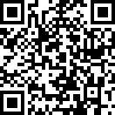

Blk:

28 Unit No.:

#05-02

QR Code For Room Transfer

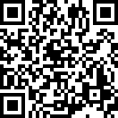

Blk:

28 Unit No.:

#05-03

QR Code For Room Transfer

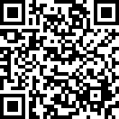

Blk:

28 Unit No.:

#05-04

QR Code For Room Transfer

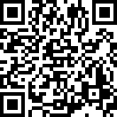

Blk:

28 Unit No.:

#05-05

QR Code For Room Transfer

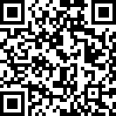

Blk:

28 Unit No.:

#05-06

QR Code For Room Transfer



Blk:

28 Unit No.:

#05-07

QR Code For Room Transfer

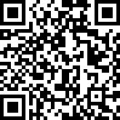

Blk:

28 Unit No.:

#05-08

QR Code For Room Transfer



Blk:

28 Unit No.:

#05-09

QR Code For Room Transfer

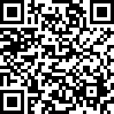

Blk:

28 Unit No.:

#05-10

QR Code For Room Transfer



Blk:

28 Unit No.:

#05-11

QR Code For Room Transfer

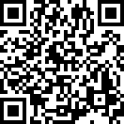

Blk:

28 Unit No.:

#05-12

QR Code For Room Transfer

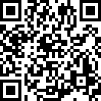

Blk:

28 Unit No.:

#05-13

QR Code For Room Transfer

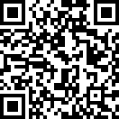

Blk:

28 Unit No.:

#05-14

QR Code For Room Transfer

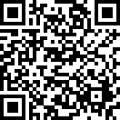

Blk:

28 Unit No.:

#05-15

QR Code For Room Transfer

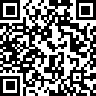

Blk:

28 Unit No.:

#05-16

QR Code For Room Transfer



Blk:

28 Unit No.:

#05-17

QR Code For Room Transfer



Blk:

28 Unit No.:

#05-18

QR Code For Room Transfer

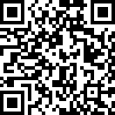

Blk:

28 Unit No.:

#06-01

QR Code For Room Transfer



Blk:

28 Unit No.:

#06-02

QR Code For Room Transfer

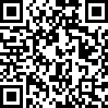

Blk:

28 Unit No.:

#06-03

QR Code For Room Transfer



Blk:

28 Unit No.:

#06-04

QR Code For Room Transfer

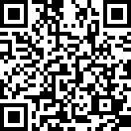

Blk:

28 Unit No.:

#06-05

QR Code For Room Transfer

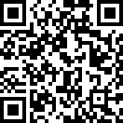

Blk:

28 Unit No.:

#06-06

QR Code For Room Transfer

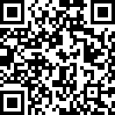

Blk:

28 Unit No.:

#06-07

QR Code For Room Transfer

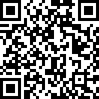

Blk:

28 Unit No.:

#06-08

QR Code For Room Transfer

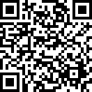

Blk:

28 Unit No.:

#06-09

QR Code For Room Transfer



Blk:

28 Unit No.:

#06-10

QR Code For Room Transfer



Blk:

28 Unit No.:

#06-11

QR Code For Room Transfer



Blk:

28 Unit No.:

#06-12

QR Code For Room Transfer

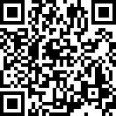

Blk:

28 Unit No.:

#06-13

QR Code For Room Transfer

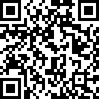

Blk:

28 Unit No.:

#06-14

QR Code For Room Transfer



Blk:

28 Unit No.:

#06-15

QR Code For Room Transfer

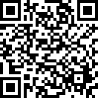

Blk:

28 Unit No.:

#06-16

QR Code For Room Transfer

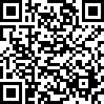

Blk:

28 Unit No.:

#06-17

QR Code For Room Transfer

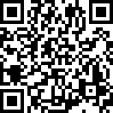

Blk:

28 Unit No.:

#06-18

QR Code For Room Transfer

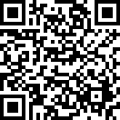

Blk:

28 Unit No.:

#07-01

QR Code For Room Transfer

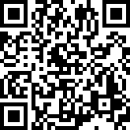

Blk:

28 Unit No.:

#07-02

QR Code For Room Transfer

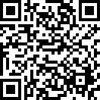

Blk:

28 Unit No.:

#07-03

QR Code For Room Transfer

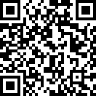

Blk:

28 Unit No.:

#07-04

QR Code For Room Transfer

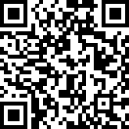

Blk:

28 Unit No.:

#07-05

QR Code For Room Transfer



Blk:

28 Unit No.:

#07-06

QR Code For Room Transfer



Blk:

28 Unit No.:

#07-07

QR Code For Room Transfer

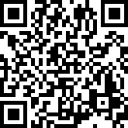

Blk:

28 Unit No.:

#07-08

QR Code For Room Transfer

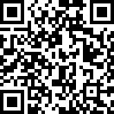

Blk:

28 Unit No.:

#07-09

QR Code For Room Transfer

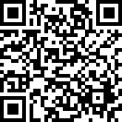

Blk:

28 Unit No.:

#07-10

QR Code For Room Transfer



Blk:

28 Unit No.:

#07-11

QR Code For Room Transfer

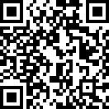

Blk:

28 Unit No.:

#07-12

QR Code For Room Transfer



Blk:

28 Unit No.:

#07-13

QR Code For Room Transfer

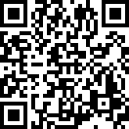

Blk:

28 Unit No.:

#07-14

QR Code For Room Transfer

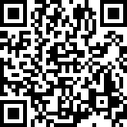

Blk:

28 Unit No.:

#07-15

QR Code For Room Transfer



Blk:

28 Unit No.:

#07-16

QR Code For Room Transfer

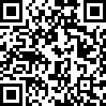

Blk:

28 Unit No.:

#07-17

QR Code For Room Transfer



Blk:

28 Unit No.:

#07-18

QR Code For Room Transfer



Blk:

28 Unit No.:

#08-01

QR Code For Room Transfer

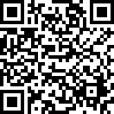

Blk:

28 Unit No.:

#08-02

QR Code For Room Transfer



Blk:

28 Unit No.:

#08-03

QR Code For Room Transfer

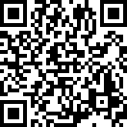

Blk:

28 Unit No.:

#08-04

QR Code For Room Transfer

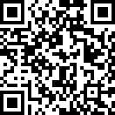

Blk:

28 Unit No.:

#08-05

QR Code For Room Transfer



Blk:

28 Unit No.:

#08-06

QR Code For Room Transfer

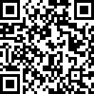

Blk:

28 Unit No.:

#08-07

QR Code For Room Transfer



Blk:

28 Unit No.:

#08-08

QR Code For Room Transfer

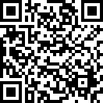

Blk:

28 Unit No.:

#08-09

QR Code For Room Transfer

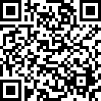

Blk:

28 Unit No.:

#08-10

QR Code For Room Transfer

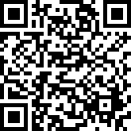

Blk:

28 Unit No.:

#08-11

QR Code For Room Transfer



Blk:

28 Unit No.:

#08-12

QR Code For Room Transfer

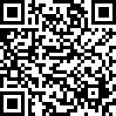

Blk:

28 Unit No.:

#08-13

QR Code For Room Transfer

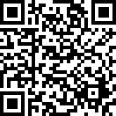

Blk:

28 Unit No.:

#08-14

QR Code For Room Transfer

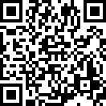

Blk:

28 Unit No.:

#08-15

QR Code For Room Transfer

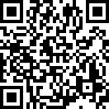

Blk:

28 Unit No.:

#08-16

QR Code For Room Transfer

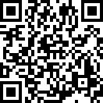

Blk:

28 Unit No.:

#08-17

QR Code For Room Transfer



Blk:

28 Unit No.:

#08-18

QR Code For Room Transfer

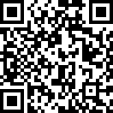

Blk:

28 Unit No.:

#09-01

QR Code For Room Transfer

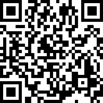

Blk:

28 Unit No.:

#09-02

QR Code For Room Transfer

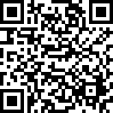

Blk:

28 Unit No.:

#09-03

QR Code For Room Transfer



Blk:

28 Unit No.:

#09-04

QR Code For Room Transfer

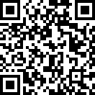

Blk:

28 Unit No.:

#09-05

QR Code For Room Transfer



Blk:

28 Unit No.:

#09-06

QR Code For Room Transfer

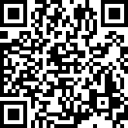

Blk:

28 Unit No.:

#09-07

QR Code For Room Transfer

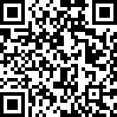

Blk:

28 Unit No.:

#09-08

QR Code For Room Transfer

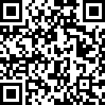

Blk:

28 Unit No.:

#09-09

QR Code For Room Transfer



Blk:

28 Unit No.:

#09-10

QR Code For Room Transfer



Blk:

28 Unit No.:

#09-11

QR Code For Room Transfer



Blk:

28 Unit No.:

#09-12

QR Code For Room Transfer

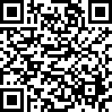

Blk:

28 Unit No.:

#09-13

QR Code For Room Transfer

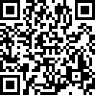

Blk:

28 Unit No.:

#09-14

QR Code For Room Transfer



Blk:

28 Unit No.:

#09-15

QR Code For Room Transfer



Blk:

28 Unit No.:

#09-16

QR Code For Room Transfer



Blk:

28 Unit No.:

#09-17

QR Code For Room Transfer



Blk:

28 Unit No.:

#09-18

QR Code For Room Transfer

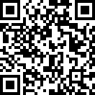

Blk:

28 Unit No.:

#10-01

QR Code For Room Transfer

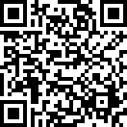

Blk:

28 Unit No.:

#10-02

QR Code For Room Transfer

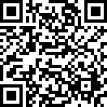

Blk:

28 Unit No.:

#10-03

QR Code For Room Transfer

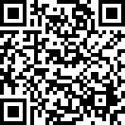

Blk:

28 Unit No.:

#10-04

QR Code For Room Transfer

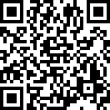

Blk:

28 Unit No.:

#10-05

QR Code For Room Transfer

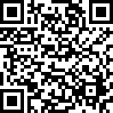

Blk:

28 Unit No.:

#10-06

QR Code For Room Transfer

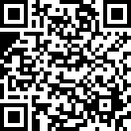

Blk:

28 Unit No.:

#10-07

QR Code For Room Transfer

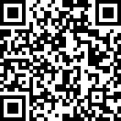

Blk:

28 Unit No.:

#10-08

QR Code For Room Transfer



Blk:

28 Unit No.:

#10-09

QR Code For Room Transfer

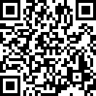

Blk:

28 Unit No.:

#10-10

QR Code For Room Transfer

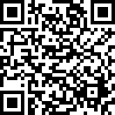

Blk:

28 Unit No.:

#10-11

QR Code For Room Transfer



Blk:

28 Unit No.:

#10-12

QR Code For Room Transfer



Blk:

28 Unit No.:

#10-13

QR Code For Room Transfer

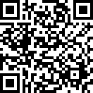

Blk:

28 Unit No.:

#10-14

QR Code For Room Transfer

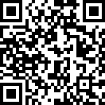

Blk:

28 Unit No.:

#10-15

QR Code For Room Transfer

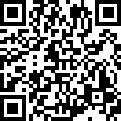

Blk:

28 Unit No.:

#10-16

QR Code For Room Transfer



Blk:

28 Unit No.:

#10-17

QR Code For Room Transfer



Blk:

28 Unit No.:

#10-18

QR Code For Room Transfer

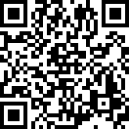

Blk:

28 Unit No.:

#11-01

QR Code For Room Transfer



Blk:

28 Unit No.:

#11-02

QR Code For Room Transfer



Blk:

28 Unit No.:

#11-03

QR Code For Room Transfer

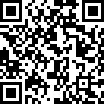

Blk:

28 Unit No.:

#11-04

QR Code For Room Transfer

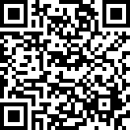

Blk:

28 Unit No.:

#11-05

QR Code For Room Transfer

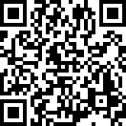

Blk:

28 Unit No.:

#11-06

QR Code For Room Transfer

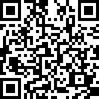

Blk:

28 Unit No.:

#11-07

QR Code For Room Transfer

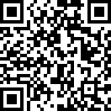

Blk:

28 Unit No.:

#11-08

QR Code For Room Transfer

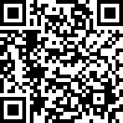

Blk:

28 Unit No.:

#11-09

QR Code For Room Transfer

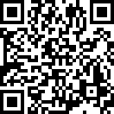

Blk:

28 Unit No.:

#11-10

QR Code For Room Transfer

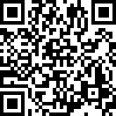

Blk:

28 Unit No.:

#11-11

QR Code For Room Transfer



Blk:

28 Unit No.:

#11-12

QR Code For Room Transfer



Blk:

28 Unit No.:

#11-13

QR Code For Room Transfer

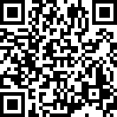

Blk:

28 Unit No.:

#11-14

QR Code For Room Transfer



Blk:

28 Unit No.:

#11-15

QR Code For Room Transfer

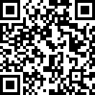

Blk:

28 Unit No.:

#11-16

QR Code For Room Transfer



Blk:

28 Unit No.:

#11-17

QR Code For Room Transfer



Blk:

28 Unit No.:

#11-18

QR Code For Room Transfer

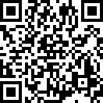

Blk:

28 Unit No.:

#12-01

QR Code For Room Transfer



Blk:

28 Unit No.:

#12-02

QR Code For Room Transfer



Blk:

28 Unit No.:

#12-03

QR Code For Room Transfer

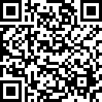

Blk:

28 Unit No.:

#12-04

QR Code For Room Transfer



Blk:

28 Unit No.:

#12-05

QR Code For Room Transfer

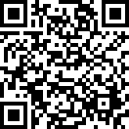

Blk:

28 Unit No.:

#12-06

QR Code For Room Transfer

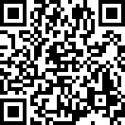

Blk:

28 Unit No.:

#12-07

QR Code For Room Transfer

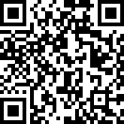

Blk:

28 Unit No.:

#12-08

QR Code For Room Transfer

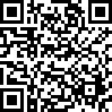

Blk:

28 Unit No.:

#12-09

QR Code For Room Transfer



Blk:

28 Unit No.:

#12-10

QR Code For Room Transfer

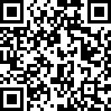

Blk:

28 Unit No.:

#12-11

QR Code For Room Transfer



Blk:

28 Unit No.:

#12-12

QR Code For Room Transfer



Blk:

28 Unit No.:

#12-13

QR Code For Room Transfer



Blk:

28 Unit No.:

#12-14

QR Code For Room Transfer



Blk:

28 Unit No.:

#12-15

QR Code For Room Transfer

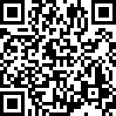

Blk:

28 Unit No.:

#12-16

QR Code For Room Transfer

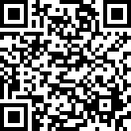

Blk:

28 Unit No.:

#12-17

QR Code For Room Transfer

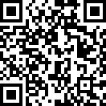

Blk:

28 Unit No.:

#12-18

QR Code For Room Transfer



Blk:

28 Unit No.:

#13-01

QR Code For Room Transfer

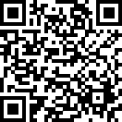

Blk:

28 Unit No.:

#13-02

QR Code For Room Transfer

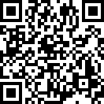

Blk:

28 Unit No.:

#13-03

QR Code For Room Transfer

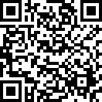

Blk:

28 Unit No.:

#13-04

QR Code For Room Transfer

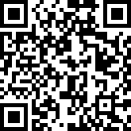

Blk:

28 Unit No.:

#13-05

QR Code For Room Transfer

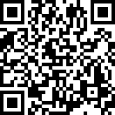

Blk:

28 Unit No.:

#13-06

QR Code For Room Transfer



Blk:

28 Unit No.:

#13-07

QR Code For Room Transfer



Blk:

28 Unit No.:

#13-08

QR Code For Room Transfer

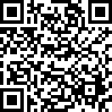

Blk:

28 Unit No.:

#13-09

QR Code For Room Transfer

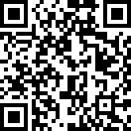

Blk:

28 Unit No.:

#13-10

QR Code For Room Transfer



Blk:

28 Unit No.:

#13-11

QR Code For Room Transfer



Blk:

28 Unit No.:

#13-12

QR Code For Room Transfer

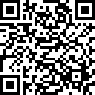

Blk:

28 Unit No.:

#13-13

QR Code For Room Transfer

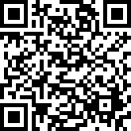

Blk:

28 Unit No.:

#13-14

QR Code For Room Transfer

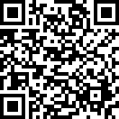

Blk:

28 Unit No.:

#13-15

QR Code For Room Transfer

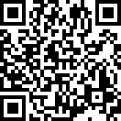

Blk:

28 Unit No.:

#13-16

QR Code For Room Transfer

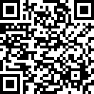

Blk:

28 Unit No.:

#13-17

QR Code For Room Transfer

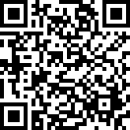

Blk:

28 Unit No.:

#13-18

QR Code For Room Transfer

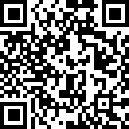

Blk:

28 Unit No.:

#14-01

QR Code For Room Transfer

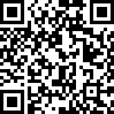

Blk:

28 Unit No.:

#14-02

QR Code For Room Transfer

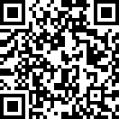

Blk:

28 Unit No.:

#14-03

QR Code For Room Transfer

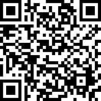

Blk:

28 Unit No.:

#14-04

QR Code For Room Transfer

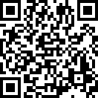

Blk:

28 Unit No.:

#14-05

QR Code For Room Transfer

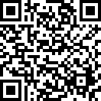

Blk:

28 Unit No.:

#14-06

QR Code For Room Transfer

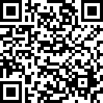

Blk:

28 Unit No.:

#14-07

QR Code For Room Transfer



Blk:

28 Unit No.:

#14-08

QR Code For Room Transfer



Blk:

28 Unit No.:

#14-09

QR Code For Room Transfer



Blk:

28 Unit No.:

#14-10

QR Code For Room Transfer

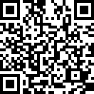

Blk:

28 Unit No.:

#14-11

QR Code For Room Transfer



Blk:

28 Unit No.:

#14-12

QR Code For Room Transfer



Blk:

28 Unit No.:

#14-13

QR Code For Room Transfer



Blk:

28 Unit No.:

#14-14

QR Code For Room Transfer



Blk:

28 Unit No.:

#14-15

QR Code For Room Transfer

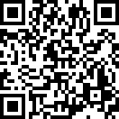

Blk:

28 Unit No.:

#14-16

QR Code For Room Transfer



Blk:

28 Unit No.:

#14-17

QR Code For Room Transfer



Blk:

28 Unit No.:

#14-18

QR Code For Room Transfer

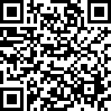

Blk:

28 Unit No.:

#15-01

QR Code For Room Transfer



Blk:

28 Unit No.:

#15-02

QR Code For Room Transfer

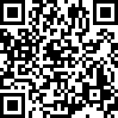

Blk:

28 Unit No.:

#15-03

QR Code For Room Transfer

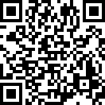

Blk:

28 Unit No.:

#15-04

QR Code For Room Transfer

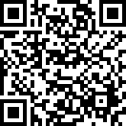

Blk:

28 Unit No.:

#15-05

QR Code For Room Transfer



Blk:

28 Unit No.:

#15-06

QR Code For Room Transfer

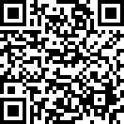

Blk:

28 Unit No.:

#15-07

QR Code For Room Transfer

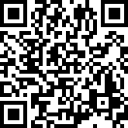

Blk:

28 Unit No.:

#15-08

QR Code For Room Transfer



Blk:

28 Unit No.:

#15-09

QR Code For Room Transfer

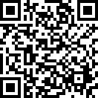

Blk:

28 Unit No.:

#15-10

QR Code For Room Transfer



Blk:

28 Unit No.:

#15-11

QR Code For Room Transfer

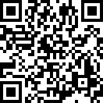

Blk:

28 Unit No.:

#15-12

QR Code For Room Transfer

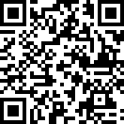

Blk:

28 Unit No.:

#15-13

QR Code For Room Transfer



Blk:

28 Unit No.:

#15-14

QR Code For Room Transfer



Blk:

28 Unit No.:

#15-15

QR Code For Room Transfer

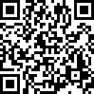

Blk:

28 Unit No.:

#15-16

QR Code For Room Transfer



Blk:

28 Unit No.:

#15-17

QR Code For Room Transfer

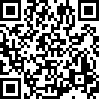

Blk:

28 Unit No.:

#15-18

QR Code For Room Transfer



Blk:

28 Unit No.:

#16-01

QR Code For Room Transfer



Blk:

28 Unit No.:

#16-02

QR Code For Room Transfer

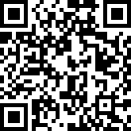

Blk:

28 Unit No.:

#16-03

QR Code For Room Transfer



Blk:

28 Unit No.:

#16-04

QR Code For Room Transfer

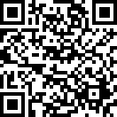

Blk:

28 Unit No.:

#16-05

QR Code For Room Transfer



Blk:

28 Unit No.:

#16-06

QR Code For Room Transfer

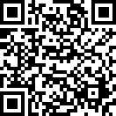

Blk:

28 Unit No.:

#16-07

QR Code For Room Transfer

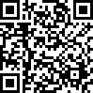

Blk:

28 Unit No.:

#16-08

QR Code For Room Transfer

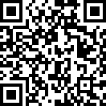

Blk:

28 Unit No.:

#16-09

QR Code For Room Transfer



Blk:

28 Unit No.:

#16-10

QR Code For Room Transfer



Blk:

28 Unit No.:

#16-11

QR Code For Room Transfer



Blk:

28 Unit No.:

#16-12

QR Code For Room Transfer

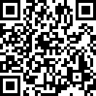

Blk:

28 Unit No.:

#16-13

QR Code For Room Transfer

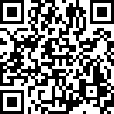

Blk:

28 Unit No.:

#16-14

QR Code For Room Transfer

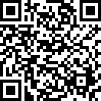

Blk:

28 Unit No.:

#16-15

QR Code For Room Transfer



Blk:

28 Unit No.:

#16-16

QR Code For Room Transfer

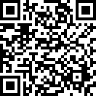

Blk:

28 Unit No.:

#16-17

QR Code For Room Transfer

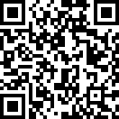

Blk:

28 Unit No.:

#16-18

QR Code For Room Transfer

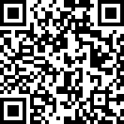

Blk:

28 Unit No.:

#17-01

QR Code For Room Transfer



Blk:

28 Unit No.:

#17-02

QR Code For Room Transfer



Blk:

28 Unit No.:

#17-03

QR Code For Room Transfer

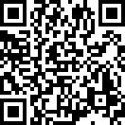

Blk:

28 Unit No.:

#17-04

QR Code For Room Transfer

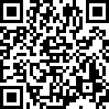

Blk:

28 Unit No.:

#17-05

QR Code For Room Transfer



Blk:

28 Unit No.:

#17-06

QR Code For Room Transfer



Blk:

28 Unit No.:

#17-07

QR Code For Room Transfer



Blk:

28 Unit No.:

#17-08

QR Code For Room Transfer

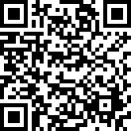

Blk:

28 Unit No.:

#17-09

QR Code For Room Transfer

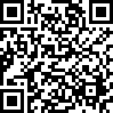

Blk:

28 Unit No.:

#17-10

QR Code For Room Transfer

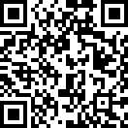

Blk:

28 Unit No.:

#17-11

QR Code For Room Transfer

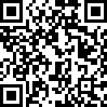

Blk:

28 Unit No.:

#17-12

QR Code For Room Transfer

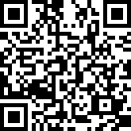

Blk:

28 Unit No.:

#17-13

QR Code For Room Transfer



Blk:

28 Unit No.:

#17-14

QR Code For Room Transfer



Blk:

28 Unit No.:

#17-15

QR Code For Room Transfer



Blk:

28 Unit No.:

#17-16

QR Code For Room Transfer



Blk:

28 Unit No.:

#17-17

QR Code For Room Transfer



Blk:

28 Unit No.:

#17-18

QR Code For Room Transfer

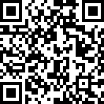

Blk:

28 Unit No.:

#18-01

QR Code For Room Transfer



Blk:

28 Unit No.:

#18-02

QR Code For Room Transfer



Blk:

28 Unit No.:

#18-03

QR Code For Room Transfer



Blk:

28 Unit No.:

#18-04

QR Code For Room Transfer

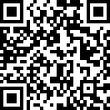

Blk:

28 Unit No.:

#18-05

QR Code For Room Transfer

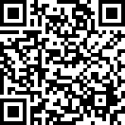

Blk:

28 Unit No.:

#18-06

QR Code For Room Transfer

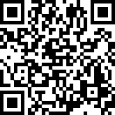

Blk:

28 Unit No.:

#18-07

QR Code For Room Transfer

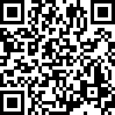

Blk:

28 Unit No.:

#18-08

QR Code For Room Transfer



Blk:

28 Unit No.:

#18-09

QR Code For Room Transfer



Blk:

28 Unit No.:

#18-10

QR Code For Room Transfer



Blk:

28 Unit No.:

#18-11

QR Code For Room Transfer

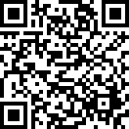

Blk:

28 Unit No.:

#18-12

QR Code For Room Transfer



Blk:

28 Unit No.:

#18-13

QR Code For Room Transfer

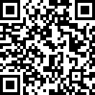

Blk:

28 Unit No.:

#18-14

QR Code For Room Transfer

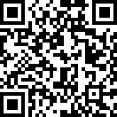

Blk:

28 Unit No.:

#18-15

QR Code For Room Transfer

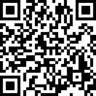

Blk:

28 Unit No.:

#18-16

QR Code For Room Transfer



Blk:

28 Unit No.:

#18-17

QR Code For Room Transfer



Blk:

28 Unit No.:

#18-18

